Moniruddin Moni (C161043)

Asif Talukdar (C161049)

MONIRUDDIN MONI (C161043)

ASIF TALUKDAR (C161049)

PROJECT Submitted in Fulfilment FOR the degree of  
B. Sc. in COMPUTER SCIENCE AND ENGINEERING

Departmrnt of Computer Science and Engineering (CSE)   
INTERNATIONAL ISLAMIC UNIVERSITY CHITTAGONG (IIUC)  
Chittagonh, Bangladesh

DECLARATION

We hereby declare that the work in this project is our own except for quotations and summaries which have been duly acknowledged.

|  |  |
| --- | --- |
| 15 February 2021 | MONIRUDDIN MONI (C161043)  ASIF TALUKDAR (C161049) |

SUPERVISOR’S DECLARATION

I hereby declare that I have read this project and in my opinion this thesis is sufficient in term of scope and quality for the award of the degree of B. Sc. in Computer Science & Engineering

|  |  |
| --- | --- |
| 15 February 2021 | Md. Mahmudur Rahman  Assistant Professor, Dept. CSE, IIUC |

DECLARATION OF THESIS / PROJECT REPORT AND COPYRIGHT

THESIS / PROJECT REPORT TITLE:

Handwritten

AUTHORS:

|  |  |  |  |
| --- | --- | --- | --- |
| SL NO. | AUTHOR’S NAME | STUDENT ID | SIGNATURE |
| 1 | MONIRUDDIN MONI | C161043 |  |
| 2 | ASIF TALUKDAR | C161049 |  |
| 3 | Handwritten |  |  |
| Name OF SUPERVISOR: Md. Mahmudur Rahman  SIGNATURE OF SUPERVISOR: | | | |

I declare

1. My/ Our thesis to be published as online open access (full text) at IIUC database or archive.

2. Dept. of CSE, IIUC reserves the right as follows:

i. The thesis is the property of Dept. of CSE, IIUC

ii. The Library of IIUC has the right to make copies for the purpose of research only.

iii. The Library has the right to make copies of the thesis for academic exchange.

ACKNOWLEDGEMENT

First and foremost praise be to Almighty Allah for all his blessings for giving me patience and good health throughout the duration of this project..

I am very fortunate to have Assistant Professor Md. Mahmudur Rahman as a project supervisor.

Moreover, I am grateful to the faculties and staffs of the Dept. of CSE, IIUC

I would like to thank all.

To my dearest …

Last but not least, I gratefully acknowledge…

ABSTRACT

Smart Classroom & Notice Management system is an Innovative technology-based web application where a teacher or student can easily take their class via this system and teacher can also give resources in the classroom. In this system teacher can create classroom and a class code was generate automatically, by this code a student can join this respective class. Here teacher have some right to manage his student, and also give assignment to the classroom. We used different well-known programming languages and frameworks to make our design more attractive to our users. As in this step coding and design are very important to develop the system. So we carefully choose those languages and frameworks to design our system so that all users can use this system properly. And we have followed all kinds of criteria of the software development process during the development of the system. And we tested our system according to the software testing process after completing the project.

TABLE OF CONTENTS

|  | Page |
| --- | --- |

DECLARATION ii

SUPERVISOR’S DECLARATION iii

DECLARATION OF THESIS / PROJECT REPORT AND COPYRIGHT iv

ACKNOWLEDGEMENT v

ABSTRACT vi

TABLE OF CONTENTS vii

LIST OF TABLES xi

LIST OF ILLUSTRATIONS xii

LIST OF ABBREVIATIONS xiii

CHAPTER I Introduction

1.1 Objectives 1**Error! Bookmark not defined.**

1.2 Scope **Error! Bookmark not defined.**

1.3 Problems of Existing System **Error! Bookmark not defined.**

CHAPTER II Background sTUDy

2.1 Proposed System **Error! Bookmark not defined.**

2.2 Our Proposal 0

2.2.1 Why is our system better **Error! Bookmark not defined.**

2.2.1.1 Admin **Error! Bookmark not defined.**

2.3.1.2 Student **Error! Bookmark not defined.**

2.3.1.3 Teacher **Error! Bookmark not defined.**

CHAPTER III Methodology

3.1 Software/Application Development Life Cycle **Error! Bookmark not defined.**

3.1.1 Requirement collection and analysis **Error! Bookmark not defined.**

3.1.2 Feasibility study **Error! Bookmark not defined.**

3.1.3 Teacher **Error! Bookmark not defined.**

3.1.4 Admin **Error! Bookmark not defined.**

3.1.5 Student **Error! Bookmark not defined.**

3.1.6 Teacher **Error! Bookmark not defined.**

3.1.7 Admin **Error! Bookmark not defined.**

3.2 Gantt Chart **Error! Bookmark not defined.**

CHAPTER IV Requirement Engineering

4.1 Introduction **Error! Bookmark not defined.**

4.2 Requirements Engineering Process Model **Error! Bookmark not defined.**

4.2.1 Requirement Analysis/Elicitation **Error! Bookmark not defined.**

4.2.2 Requirement Specification **Error! Bookmark not defined.**

4.2.3 Requirement Validation **Error! Bookmark not defined.**

4.3 Stakeholders of Smart Classroom & Notice Management System **Error! Bookmark not defined.**

4.4 Feasibility Study **Error! Bookmark not defined.**

4.5 Objectives of Feasibility Study **Error! Bookmark not defined.**

CHAPTER V System Analysis

5.1 Functional requirements **Error! Bookmark not defined.**

5.2 Administrators **Error! Bookmark not defined.**

5.2.1 Scrap, products Pricing Information **Error! Bookmark not defined.**

5.2.2 Environmental Blog post **Error! Bookmark not defined.**

5.2.3 Selling and Cancellation **Error! Bookmark not defined.**

5.3 User **Error! Bookmark not defined.**

5.4 Non-functional requirement **Error! Bookmark not defined.**

5.3 Conclusion **Error! Bookmark not defined.**

CHAPTER Vi Software Design

6.1 Software Design Description **Error! Bookmark not defined.**

6.2 Use Case Diagram **Error! Bookmark not defined.**

6.2.1 Use case of Admin **Error! Bookmark not defined.**

6.2.2 Use case of Users **Error! Bookmark not defined.**

6.2.3 Use case of Vendors **Error! Bookmark not defined.**

6.3 Data Flow Diagram (DFD) **Error! Bookmark not defined.**

6.3.1 Context Level DFD **Error! Bookmark not defined.**

6.3.2 Level 1 DFD **Error! Bookmark not defined.**

CHAPTER Vii Database Design

7.1 Entity Relationship Diagram **Error! Bookmark not defined.**

7.1.1 Entity **Error! Bookmark not defined.**

7.1.2 Attribute **Error! Bookmark not defined.**

7.1.3 Relationship **Error! Bookmark not defined.**

7.1.4 Cardinalities **Error! Bookmark not defined.**

7.2 ERD of Our System **Error! Bookmark not defined.**

7.3 Database **Error! Bookmark not defined.**

CHAPTER Viii Implementation

8.1 Technologies used **Error! Bookmark not defined.**

8.2 Tools Used **Error! Bookmark not defined.**

8.3 Test Server **Error! Bookmark not defined.**

8.4 Software **Error! Bookmark not defined.**

8.5 Interface Design **Error! Bookmark not defined.**

8.5.1 Design Page **Error! Bookmark not defined.**

CHAPTER iX Testing

9.1 Testing **Error! Bookmark not defined.**

9.2 Testing Methods **Error! Bookmark not defined.**

9.3 Basic of software testing **Error! Bookmark not defined.**

9.3.1 Black Box Testing **Error! Bookmark not defined.**

9.3.2 White Box Testing **Error! Bookmark not defined.**

9.4 Types of Testing **Error! Bookmark not defined.**

9.4.1 Unit Testing **Error! Bookmark not defined.**

9.4.2 Integration Testing **Error! Bookmark not defined.**

9.5 Conclusion **Error! Bookmark not defined.**

CHAPTER X Conclusion & Reference

10.1 Future Plan of OUR Project **Error! Bookmark not defined.**

10.2 References **Error! Bookmark not defined.**

References Error! Bookmark not defined.

Appendices

Appendix A Questionnaire **Error! Bookmark not defined.**

Appendix B Please give a title for this Appendix **Error! Bookmark not defined.**

Appendix C Please give a title for this Appendix **Error! Bookmark not defined.**

Appendix D Put a title here **Error! Bookmark not defined.**

LIST OF TABLES

|  |  |
| --- | --- |
| Table No. | Page |

Table ‎2.1 First table in specific objective for Chapter II **Error! Bookmark not defined.**

Table ‎2.3 First table in specific objective for chapte II **Error! Bookmark not defined.**

Table ‎2.4 Second table in specific objective for chapter II and the title is long, very long so that caption-justify can be use **Error! Bookmark not defined.**

Table ‎3.1 First table in specific objective for Chapte II **Error! Bookmark not defined.**

Table ‎3.2 Second table in specific objective for Chapter II and the title is long. Very long so that caption-justify can be use **Error! Bookmark not defined.**

Table ‎4.1 First table in specific objective for Chapter II **Error! Bookmark not defined.**

Table ‎4.2 Second table in specific objective for Chapter II and the title is long, very long so that caption-justify can be use **Error! Bookmark not defined.**

Table ‎5.1 First table in specific objective for Chapter II **Error! Bookmark not defined.**

Table ‎5.2 First table in specific objective for Chapter II **Error! Bookmark not defined.**

LIST OF ILLUSTRATIONS

|  |  |
| --- | --- |
| Figure No. | Page |

Figure ‎1.1 First figure **Error! Bookmark not defined.**

Figure ‎1.2 Second figure **Error! Bookmark not defined.**

Figure ‎1.3 Third figure **Error! Bookmark not defined.**

Figure ‎3.1 Give this figure a title (using Style: 15a Caption-Center) **Error! Bookmark not defined.**

|  |  |
| --- | --- |
| Photo No. |  |

LIST OF ABBREVIATIONS

AELB Atomic Energy Licensing Board

IAEA International Atomic Energy Agency

UKM Universiti Kebangsaan Malaysia

# Introduction

cHAPTER 1

INTRODUCTION

In the pandemic period our classes are being held online and we are facing problems of maintaining class and exams time schedule. Many students could not attend class on scheduled time. These problems are happened due to lack of proper management. Class schedules, notices are scattered in different places, so it is very difficult to maintain them in a proper way. Therefore we need a platform where all necessary information would be aggregated and arranged in a well manner.

So we created a web based online classroom named as "Smart Classroom & Notice Management System" .The web application have three panels where system admin manages students and teachers . Teacher create classroom and give the classroom code to the students by that they can easily join the respective class . Here teacher share all the class materials to the students by post and student can easily get the material and give their feedback in commentbox.

* + 1. Objectives

The main purpose of this project is to reduce hassle during online class environmental pollution and to solve the traditional scrap collection system and to promote eco-friendly products. The objectives of this system are to-

1 To develop such a web based system where both students and faculty members will be able to get the information about class schedules, department notice & students attendance.

2. To eradicate students suffering, teachers will provide all resources by using this system.

3. To the help of students and teacher, all types of departments notice will be publish here

1.2 Scope

In this project, the scope is to help the student and teacher, so that teacher can easily create class and student can join respective class by class code, here teacher gave all the resources and news by post. The scopes of this system are:

1. Easy to create class

2. Easy to join class

3. Teacher can share material in classroom.

4. Teacher give assignments.

5. Student can submit their assignments.

1.3 Problems of Existing System

Due to pandemic our daily life, education all is contracted within the boundary wall of our houses. Especially education system is been through a massive change circumstances. We have to conduct our class lectures, exams over the internet. Our beloved dept. of CSE is also following the trend, but it is a matter of sorrow that there is no such convenient system has been used by our department to fully comply with the digital education or education over internet.

The faculty members of our department have to face a lot of work burden about the class schedule, assignments, exams, viva etc. Convey of any notice or any news to the students is time taking hazardous. Social media is used as the only platform to convey notices and news to the students. So that most of the time students were unable to receive proper notice in proper time.

* + 1. Chapterii  
       Literature review

2.1 Introduction

A literature review discusses published information in a particular subject area, and sometimes information in a particular subject area within a certain time period. A literature review can be just a simple summary of the sources, but it usually has an organizational pattern and combines both summary and synthesis. A summary is a recap of the important information of the source, but a synthesis is a reorganization, or a reshuffling, of that information.

2.2 Review of related work

We already have introduced Google Classroom through in the internet. In google classroom there is not a single or common notice board available in this classroom where students of CSE, IIUC can get their necessary information from this system . In google classroom there are no attendance system.So that teachers can't take student attendance.

2.3 Comparison of our system

We build a notice board where teacher and admin easily give department notice and all the registered student get all notices in the noticeboard ,thus no valuable information isn't missing and also in our system we create attendance system to eradicate attendance taking problem .This is the reason behind our proposed project where we want to solve this problem.

* 1. Methodology

Software Engineering is the practice of using selected process techniques to improve the quality of a software development effort. We have followed a methodology that helped us to develop the system in an organized way. This is based on the assumption that subject to endless debate and supported by patient experience, a systematic approach to software development results in fewer defects and, therefore, ultimately provides shorter delivery time and better value. We have used the waterfall model(Web) and MVC architecture (Laravel) in our system. The document collection of policies, processes, and procedures used by our development team to use the software engineering process is the software development life cycle (SDLC)

3.1 Software/Application Development Life Cycle

The Software Development Life Cycle (SDLC) refers to a methodology with clearly defined processes for creating high-quality software. in detail, we followed the SDLC methodology focuses on the following phases of system development:

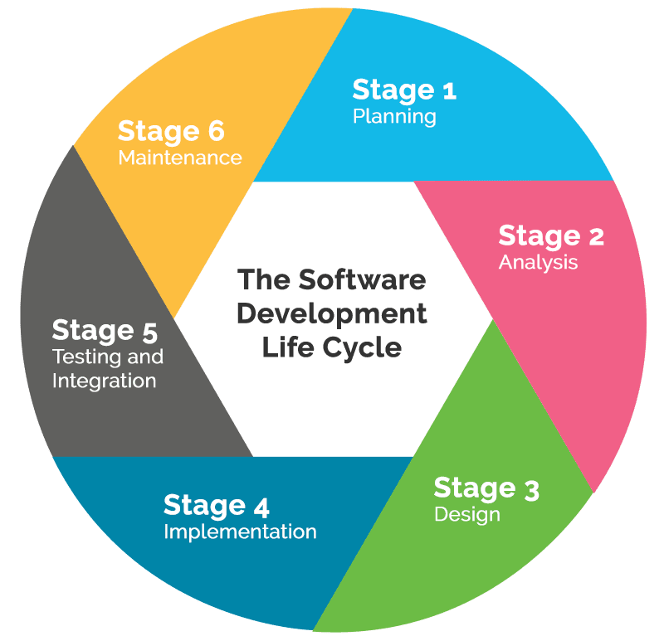

3.1 1: Requirement collection and analysis:

The requirement is the first stage in the SDLC process. We conduct it as a team with inputs from all the stakeholders and domain experts or this industry. Planning for the quality assurance requirements and recognition of the risks involved is also done at this stage. We had done an online and offline survey for requirement collection and analysis. In this stage, we try to give a clearer picture of the entire project's scope and the anticipated issues, opportunities, and directives that triggered the task with proper data.

Requirements Gathering stage, we tried to get detailed and precise requirements. This helps us to finalize the necessary timeline to finish the work of that system.

3.1.2: Feasibility study:

Once the requirement analysis phase is completed, the next SDLC step is to define and document software needs. This process we conducted with the help of the 'Software Requirement Specification' document, also known as the 'SRS' document. We collect all project-related data, which shows the results that the system is feasible to develop. It includes everything which should be designed and developed during the project life cycle. According to all collected data, we can say that our development system is feasible for users and development according to all criteria.

There are mainly five types of feasibilities checks:

● Economic: We have completed development for the project within the budget.

● Legal: We handle this project as cyber law and other regulatory frameworks /compliances.

● Operation feasibility: Users and we can operate the system easily

● Technical: System is suitable for all devices and technically feasible

● Schedule: The project can be completed within the expected schedule.

3.1.3: Design:

In this third phase, the system and Application design documents have been prepared as per the requirement specification document. This helps define the overall system architecture. This design phase serves as input for the next step of the model. There are two kinds of design documents developed in this phase:

### High-Level Design (HLD)

- Brief description and name of each module

- An outline of the functionality of every module

- Interface relationship and dependencies between modules

- Database tables identified along with their key elements

- Complete architecture diagrams along with technology details

Low-Level Design(LLD)

- Functional logic of the modules

- Database tables, which include type and size

- Complete detail of the interface

- Addresses all types of dependency issues

- Listing of error messages

- Complete input and outputs for every module

3.1.4: Coding:

Once the system design phase is over, the next phase is coding. In this phase, we have started to build the entire system by writing code using the chosen object oriented programming language which is PHP. In the coding phase, tasks are divided into units or modules and assigned to the team. It is the longest phase of the Software Development Life Cycle process that developing the project with coding takes time.

3.1.5: Testing:

Once the software is complete, it is deployed in the testing environment. Our team started testing the functionality of the entire system. This is done to verify that the entire application works according to the requirement initially. During this phase, we try to find some bugs/defects which we can fix. This process continues until the software is bug-free, stable, and working according to requirements.

3.1.6: Installation/Deployment:

Once the software/application testing phase is over and some bugs or errors occur which we tried to resolve and in the system then the final deployment process starts. Based on the feedback given by users, the final software is prepared to release and check for deployment issues if any.

3.1.7: Maintenance:

Once the system is deployed, and test users start using the developed system, following 3 activities occur

-Bug fixing - bugs are reported because of some scenarios which are not tested at all

-Upgrade - Upgrading the application to the newer versions of the Software

-Enhancement - Adding some new features into the existing software

The main focus of this SDLC phase is to ensure that needs continue to be met and that the system continues to perform as per the specification mentioned in the first phase.

Implementation

In this step, we illustrate the implementation of our system. Implementation means installing the software on user machines. Many websites are created for specific systems but in our system, we try to add some new features to help the user. It will help them to create a classroom and join the class by room id more easily without facing any difficulties. We used different well-known programming languages and frameworks to make our design more attractive to our users. As in this step coding and design are very important. So we carefully choose those languages and frameworks to design our system that in future any developer can work on this project. In SDLC, step implementation is very important as it involves implementing the system.

3.2 Change Request Definition

In this step, it is needed if any request comes after delivering the system then it defines the processing of the delivered system.

|  |  |  |  |  |  |  |  |  |
| --- | --- | --- | --- | --- | --- | --- | --- | --- |
| Gantt  Chart | Week  1-2 | Week 3-4 | Week  4-5 | Week  5-6 | Week  6-7 | Week  7-8 | Week 9-10 | Week  11-12 |
| Step 1 | Requir ement Analysi  s |  |  |  |  |  |  |  |
| Step 2 |  | Architect ure |  |  |  |  |  |  |
| Step 3 |  |  | Registrat ion & Home  Design |  |  |  |  |  |
| Step4 |  |  |  | Others Section design |  |  |  |  |
| Step 6 |  |  |  |  | Backend  Start |  |  |  |
| Step 7 |  |  |  |  |  | Databas  e |  |  |
| Step8 |  |  |  |  |  |  | Total  Developm  ent |  |
| Step 9 |  |  |  |  |  |  |  | Beta Test |

3.3 Gantt Chart

Requirement Collection & Analysis​

The Software Requirement Specification Process is a document that lists out stakeholders’ needs and communicates these to the technical community that will design and build this system. It involves scoping the requirements so that it meets the customer’s needs. It allows collaboration between the end-users, who often do not have any technical knowledge, and a technical/system analyst who is likely to approach the technical terms.

4.1 Requirement Engineering

Requirement analysis is important and essential activity after elicitation. We analyze, refine, and scrutinize the gathered requirements to create consistent and unambiguous requirements. This activity reviews all requirements and should provide a graphical view of the complete system. After completing the analysis, it's expected that the project's understandability may improve significantly. Here, we might also use the customer's interaction to clarify points of confusion and grasp which requirements are more critical than others.

4.2 Requirements Engineering Process Model

We have followed all processes of Requirements Engineering to develop our system.

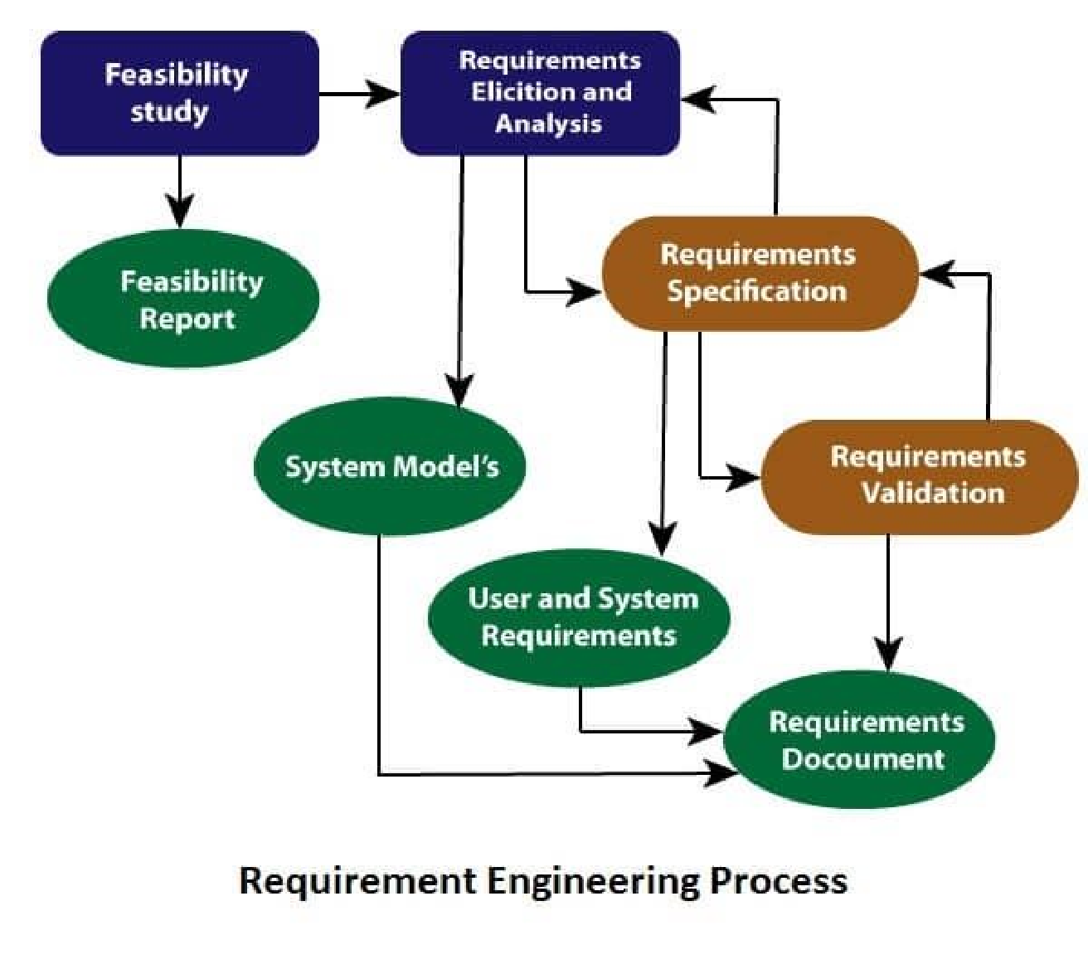

4.2.1 Requirement Analysis/Elicitation

This is also known as the gathering of requirements. Here, requirements are identified with the help of customers and existing systems processes, if available. Analysis of requirements starts with requirement elicitation. The requirements are analyzed to identify inconsistencies, defects, omissions, etc. We describe requirements in terms of relationships and also resolve conflicts, if any

● Getting all, and only, the right people involved.

● Stakeholders often don't know what they want.

● Stakeholders express requirements in their terms.

● Stakeholders may have conflicting requirements.

● Requirement change during the analysis process.

4.2.2 Requirement Specification

The software requirement specification is a kind of document which a software analyst creates after the requirements are collected from various sources - the requirement received by the customer written in ordinary language. We write the requirements in technical language so that we can be understood and beneficial by our development team.

The models used at this stage include ER diagrams, data flow diagrams (DFDs), function decomposition diagrams (FDDs), data dictionaries, etc.

4.2.3 Requirement Validation

After requirement specifications are developed, the requirements discussed in this document are validated. The user might demand an illegal, impossible solution, or experts may misinterpret the needs.

Requirements can be the check against the following conditions -

● If they can practically use

● If they are correct and as per the functionality and especially of web and application

● If there are any ambiguities

4.3 Stakeholders of Smart Classroom & Notice Management System

Administrator

Teachers

Students

4.4 Feasibility Study

Feasibility study in Software Engineering is a study to evaluate the feasibility of a proposed project or system. A feasibility study is carried out based on many purposes to analyze whether a software/ application product will be right in terms of development, implantation, contribution of the project to the organization, etc. And we analyze all for our system, which ensures that the project is feasible.

4.5 Objectives of Feasibility Study

A feasibility Study in Software Engineering is a study to evaluate feasibility of the proposed project or system. Feasibility study is one of the four stages of  Software Project Management Process.​ As the name suggests feasibility study is the feasibility analysis, or it is a measure of the software product in terms of how beneficial product development will be for the organization from a practical point of view. The feasibility study is carried out based on many purposes to analyze whether an application product will be right in terms of development, implantation, contribution of project to the organization etc.

### Types of Feasibility Study :

The feasibility study mainly concentrates on below five mentioned areas. Among these, Economic Feasibility Study is the most essential part of the feasibility analysis, and Legal Feasibility Study is less considered feasibility analysis.

### 1. Technical Feasibility –

Our developed system is technically feasible. Our proposed idea according to requirements analysis we have developed the system in most advance and latest technology. Our system is feasible in most of the devices and there is no technical fault initially and after user feedback we are working to improve. During development we used updated hardware and software for better experience.

### Technical Criteria:

For this system the minimum hardware requirements are:

Ø PC: Intel core i5 processor.

Ø RAM: 4GB

Ø Keyboard

Ø Mouse

For this system the software requirements are:

Ø OS: Windows 10

Ø Database: Mysql

Ø Server: Web server

Ø Browser: Mozilla Firefox/Google Chrome and more.

Ø Platform: Laravel, HTML, CSS, JavaScript, Xml, PHP, Visual Studio-13, Git .

### 2. Operational Feasibility –

The Operational Feasibility degree of providing service to requirements is analyzed. The operation of the site is so easy for administrators, teachers, and students. The system works on low-speed internet, medium configuration smartphones, laptops, or PC.

### 3.Economic Feasibility –

In Economic Feasibility study the cost and benefit of the project is analyzed. System is free for all. So there is no hidden cost to use the system. Development cost is also affordable. After that it is analyzed whether the project will be beneficial in terms of finance for the organization.

### 4. Legal Feasibility –

The Legal Feasibility study project is analyzed from a legal point of view. This includes analyzing barriers of the project's legal implementation, data protection acts or social media laws, project certificate, license, copyright, etc. This system is copyright free as the source code of the project is unique. And According to the law this system has no binding.

### 5. Schedule Feasibility –

In Schedule Feasibility Study, mainly timelines/deadlines are analyzed for proposed projects, which includes how many times teams will take to complete the final project, which has a significant impact on the organization as the project's purpose may fail if it can’t be completed on time. We maintain a Gantt chart to a feasible development schedule to complete the total project on time.

* 1. systemAnalysis

System Analysis is a step completed before the development of the “**Smart Classroom & Notice Management System**” web application. It shows the requirements or description of the needs and desires of an information system. A requirement describes functions, features, and constraints. Thus, system requirements define the services provided by the system and prescribe conditions for its operation. There are two types of requirements. Both these functional and non-functional requirements are discussed in this chapter.

5.1 Functional requirements

Functional requirements are the function or features that are included in an information system to satisfy the business needs and user acceptance. System Administrator and (user) can use this proposed system. Here we describe a clear and detailed functional system requirement for this system of both the Administrator section and User section.

5.2 Administrators

The System Administrator can be able to access all the functions in this system.. The functional requirements of administrators’ section are given below.

5.2.1 Create Teachers & Students

The system administrator can create student and teacher.

5.2.2 Manage teacher & student

The system administrator can edit teacher and student information.

5.2.3 post notice

The system administrator can post notice in notice board.

5.3 Teacher

Teacher create new classroom

5.3.1 Teacher interface

Teacher can view his classroom and joined students

5.3.2 Post in classroom

Teacher give resource material in classroom and also reply class comment

5.3.3 Take attendence & assignment

Teacher can take class attendance and also post notice in classroom

5.3.4 post notice

Teacher post notice in notice board

5.3.5 Student

Student join classroom via classroom code

5.3.6 View post and comment

Student can view post and comment in the post

5.3.7 View Assignment

Student can view assignment and submit the assignment

5.3.8 View profile and edit it

Student can view his profile and also edit information

5.4 Non-functional requirement

Non-functional requirements are description of the features, characteristics, and attributes of the system and any constraints that may limit the boundaries of the proposed solution. Such constraints usually narrow down the selection of programming language, operating system platform or implementation techniques. Our proposed system web portal and app ensures some certain web application qualities. These are given below-

5.4.1 Ease of Use

The system must be simple and easy to use. Documentation and user manual will be provided to the users. It ensures that the users are able to use and operate the system by themselves. Help sections or user instructions will be provided also throughout the system so that it can guide users when they face any problem.

5.4.2 Maintainability

Maintainability allows a program to correct if an error is encountered, adapted if its environment changes, or enhanced if the customer desires a change in requirement. In order to make the system easily maintained, the programs must be easily understandable by the maintenance programmer as well as easily modified and tested when updating is done to meet new requirements, rectifying a deficiency or correcting errors.

5.4.3 Reliability

Reliability is the extent to which a program can be expected to perform its intended function with requirement precision. This system should be reliable and does not produce dangerous or costly failure when it is used in a reasonable manner.

5.4.4 Robustness

Robustness refers to the ability of the system to be able to handle or continue in operation when faced with unexpected circumstances like handling improper data. The system must be robust enough to handle anticipated or unanticipated errors.

5.4.5 Response time/Speed

The system can process any operation at the highest speed. It also avoids unnecessary interaction. For a low response time, the user may get disappointed and feel frustrated, and decide not to use this system. So, our system is faster to use and interactive that users can't get bored to use, and we skip unnecessary steps, which could make the user feel that the system takes more time.

5.4.6 Security

The system has security measures to minimize the risk of data exposure to unauthorized people. Only the authorized users who have correct login with valid mail id are allowed to access. They can not manipulate the data kept in the database. Website has ssl security. All users data is confidential and we don’t share any data of users to third parties. An user must be verified himself to enter the application.

5.4.7 User-friendly

As the system is developed for the teachers & students, we hope that all are must have some technical background knowledge. So they can easily able to operate the system. Though we also build the web application with a user-friendly interface. A user-friendly system will satisfy system users and allow interaction with his website. This feature enables users to utilize this system to the maximum. The size of the web application is small, and the design is user friendly.

5.4.8 Functionality

Creating class and Notice and managed it are the most important functions of the system. This is for the web application that deal with data retrieval from the existing database. On the other hand, manipulation and browsing features as well as applications domain related features are also taken into account. All functions are designed simply that users have to face no hassle.

5.4.9 Correctness

The degree to which the software performs its required function is referred to by the correctness. Programs for the system should be operating correctly for the user to retrieve the desired output. We apply numerous testing and trial and errors are carried out to ensure this system quality.

5.5 Conclusion

Our mention section acts only as a guide for us as many other factors can be considered during implementation of our work. The framework which we suggest ensures that this project will be successful because the activities are carried out step by step.

* 1. - sySTEM deSIGN

System design is the process of designing the elements of a system such as the architecture, modules and components, the different interfaces of those components and the data that goes through that system .We design our system by following system design rules and all sections that should include in the system during development.

6.1 Software Design Description

Software analysis and design indicate all activities, which help the transformation of requirement specification into implementation. Requirement specifications specify all functional and non-functional expectations from the software. These requirement specifications are available in human-readable and understandable documents, to which a computer has nothing to try and do. Software analysis and design are at the intermediate stage, helping human-readable requirements be transformed into actual code.

6.2 Use Case Diagram

A use case diagram at its simplest is a representation of a user’s interaction with the system that shows the relationship between the user and the different use cases in which the user is involved. A use case diagram can identify the different types of users of a system and the different use cases and will often be accompanied by other types of diagrams as well.

There are four elements that are used in the diagram are:

Use Case: A use case describes a sequence of actions that provide something of measurable value to an actor and is drawn as a horizontal ellipse.

Actor: An actor is a person, organization or external system that plays a role in one or more interactions with a system. Actors are drawn as stick figures.

Association: Associations between actors and use cases are indicated in use case diagrams by solid lines. An association exists whenever an actor is involved with an interaction described by a use case. Associations are modeled as lines connecting use cases and actors to one another, with an optional arrowhead on one end of the line.

System boundary boxes: To indicate the scope of the system, a rectangle is drawn in the use cases, called system boundary boxes. Anything within the box represents functionality that is in scope and anything outside the box is not.

6.2.1 Use case of Admin

In the use case diagram of admin, admin can add, delete and update student & teacher information also post notice in the notice board.

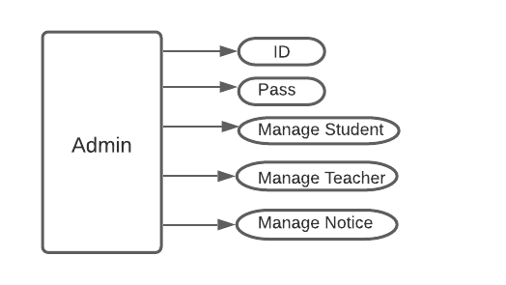

Figure 6.2.1: Use case of Admin

6.2.2 Use case of Student

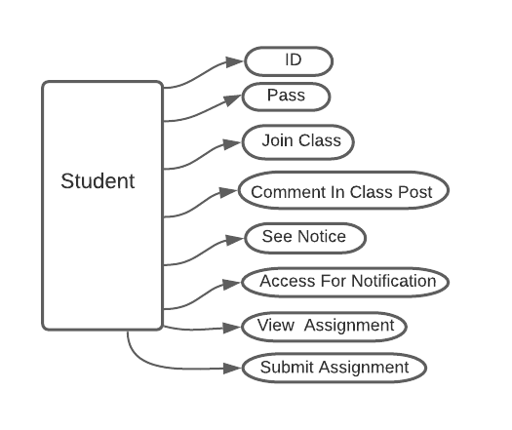

Figure 6.2.2: Use case of Student

6.2.3 Use case of Teacher:

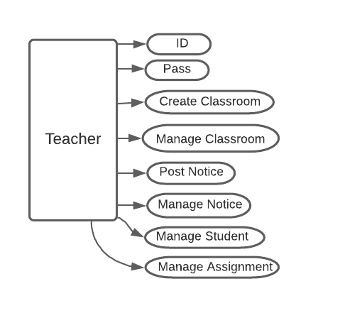

Figure 6.2.3: Use case of Vendor

6.3 Data Flow Diagram (DFD)

Data flow diagrams are a graphical representation of the flow of knowledge in an information system. It's capable of depicting incoming data flow, outgoing data flow, and stored data. The DFD doesn't mention anything about how data flows through the system.

There is a noticeable difference between DFD and Flowchart. The flowchart represents the flow of control in program modules. DFD's represent the flow of knowledge within the system at various levels. DFD doesn't contain any control or branch elements. We have used DFD to develop our system.

### Types of DFD

Data Flow Diagrams are either Logical or Physical.

Logical DFD - This type of DFD concentrates on the system process, and flow of data in the system. For example in a Banking software system, how data is moved between different entities.

Physical DFD - This type of DFD shows how the data flow is actually implemented in the system. It is more specific and close to the implementation.

### DFD Components

DFD can represent Source, destination, storage and flow of data using the following set of components -

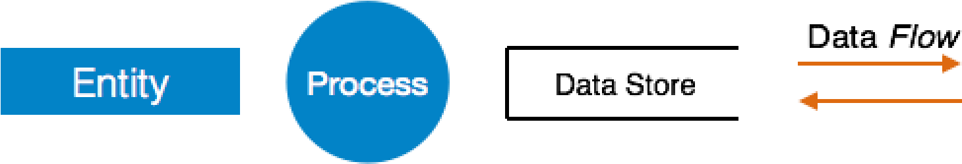

Entities - Entities are source and destination of information data. Entities are represented by rectangles with their respective names.

Process - Activities and action taken on the data are represented by Circle or Round-edged rectangles.

Data Storage - There are two variants of data storage - it can either be represented as a rectangle with absence of both smaller sides or as an open-sided rectangle with only one side missing.

Data Flow - Movement of data is shown by pointed arrows. Data movement is shown from the base of the arrow as its source towards the head of the arrow as destination.

6.3.1 Context Level DFD

A context level DFD is the most basic form of Data Flow Diagram. It is used to show how the entire system works at a glance. There is one process only in the system and all the data flows either into or out of this process. Context level DFD maintains the interactions between the process and external entities. It does not contain Data Stores.

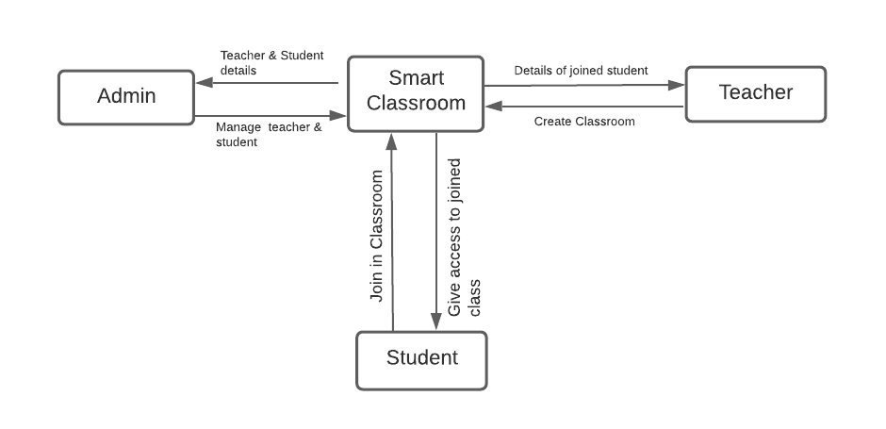

6.3.2 Level 0 DFD

It is the expansion of context diagrams. It shows the process and data flow more briefly. The figure of level 0 DFD given below:

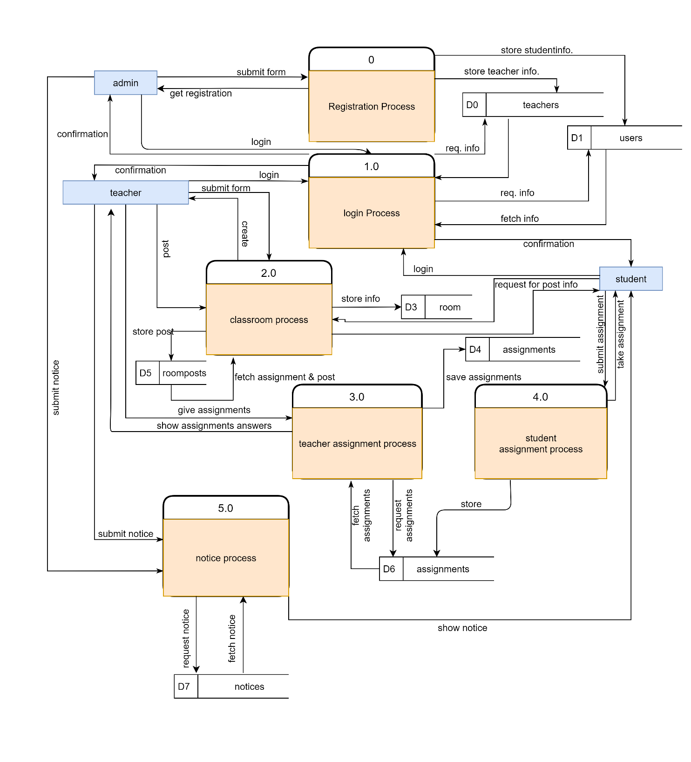

* 1. dATABASE DESIGN

7.1 Entity Relationship Diagram

An Entity–relationship model (ER model) describes the structure of a database with the help of a diagram, which is known as Entity Relationship Diagram (ER Diagram). We use an ER model as a design or blueprint of a database that can later be implemented as a database. The main components of the E-R model we used are: entity set and relationship set.

7.1.1 Entity

An entity is an object or component of data. An entity is represented as a rectangle in an ER diagram. For example: In the following ER diagram we have two entities Student and College and these two entities have many to one relationship as many students study in a single college. We will read more about relationships later, for now focus on entities.

7.1.2 Attribute

An attribute describes the property of an entity. An attribute is represented as Oval in an ER diagram. There are four types of attributes:

- Key attribute

- Composite attribute

- Multivalued attribute

- Derived attribute

7.1.3 Relationship

A relationship describes how entities interact. For example, the entity “admin” may be related to the entity “user” by the relationship “manages”. Relationships are represented by diamond shapes and are labeled using verbs.

7.1.4 Cardinalities

Cardinality is the number of entity instances to which another entity set can map under the relationship. This does not reflect a requirement that an entity has to participate in a relationship.

7.1.5 One-to-One

One instance of an entity is associated with one other instance of another entity.

7.1.6 One-to-Many

When a single instance of an entity is associated with a single instance of another entity then it is called one to one relationship. For example, a person has only one passport and a passport is given to one person.

7.1.7 Many-to-Many

When a single instance of an entity is associated with more than one instance of another entity then it is called one to many relationship. For example – a Teacher can create many class but same class cannot be created by many teachers

7.2 ERD of Our System

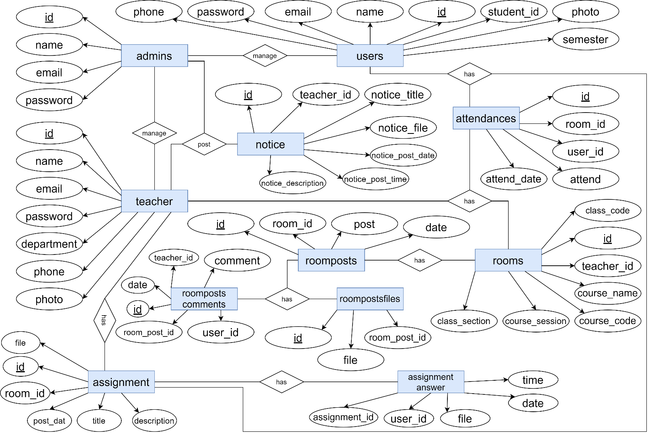

7.3 Data Dictionary

A data dictionary is a collection of descriptions of the data objects or items in a data model for the benefit of programmers and others who need to refer to them. A first step in analyzing a system of objects with which users interact is to identify each object and its relationship to other objects. This collection can be organized for reference into a book called a data dictionary.

7.4 Database

Our database is a collection of information that is organized so that it can easily be accessed, managed, and updated. The collected information could be in any number of formats (electronic, printed, graphic, audio, statistical, combinations, images). There is physical (paper/print) and electronic databases. We created a database that could be as simple as an alphabetical arrangement of names in an address book or as complex as a database that provides information in a combination of formats. As per requirement we used MySQL Database in our system.

7.5 Database Management System

Database management system (DBMS) is system software for creating and managing databases. The DBMS helps us with a systematic way to create, retrieve, update and manage data. The DBMS makes it possible for end users to create, read, update and delete data in a database. The DBMS serves as an interface between the database and end users or application programs, ensuring that data is consistently organized and remains easily accessible.

7.6 Tables of Smart Classroom & Notice Management System

7.6.1 admin:

|  |  |
| --- | --- |
| Field | Type |
| id | bigint (20) |
| |  |  | | --- | --- | | name |  | | varchar(191) |
| email | varchar(191) |
| email_verified_at | timestamp |
| password | varchar(191) |
| remember_token | varchar(100) |
| |  |  | | --- | --- | | created_at |  | | timestamp |
| updated_at | timestamp |

7.6.2 assignmentsanswers:

|  |  |
| --- | --- |
| Field | Type |
| id | bigint(20) |
| assignment_id | bigint(20) |
| user_id | varchar(191) |
| assignment_file | varchar(191) |
| assignment_submit_date | varchar(191) |
| assignment_submit_time | varchar(191) |

7.6.3 assignments:

|  |  |
| --- | --- |
| Field | Type |
| id | bigint(20) |
| room_id | bigint(20) |
| |  |  | | --- | --- | | assignment_title |  | | varchar(191) |
| |  |  | | --- | --- | | assignment_description |  | | varchar(950) |
| |  |  | | --- | --- | | assignment_file |  | | varchar(200) |
| |  |  | | --- | --- | | assignment_post_date |  | | varchar(191) |
| |  |  | | --- | --- | | assignment_post_time |  | | varchar(191 |
| |  |  | | --- | --- | | assignment_due_date |  | | varchar(191) |
| |  |  | | --- | --- | | assignment_due_time |  | | varchar(191) |

7.6.4 attendances:

|  |  |
| --- | --- |
| Field | Type |
| |  |  | | --- | --- | | id Primary |  | | bigint(20) |
| |  |  | | --- | --- | | room_id Index |  | | bigint(20) |
| |  |  | | --- | --- | | user_id |  | | bigint(20) |
| |  |  | | --- | --- | | attend |  | | varchar(191) |
| |  |  | | --- | --- | | attend_date |  | | varchar(191) |
| |  |  | | --- | --- | | updated_at |  | | varchar(140) |

7.6.5 failed_jobs

|  |  |
| --- | --- |
| Field | Type |
| |  |  | | --- | --- | | id Primary |  | | bigint(20) |
| |  |  | | --- | --- | | connection |  | | text |
| queue | text |
| |  |  | | --- | --- | | payload |  | | longtext |
| |  |  | | --- | --- | | exception |  | | longtext |
| |  |  | | --- | --- | | failed_at |  | | timestamp |

7.6.6 jobs

|  |  |
| --- | --- |
| Field | Type |
| |  |  | | --- | --- | | id Primary |  | | bigint(20) |
| |  |  | | --- | --- | | queue Index |  | | varchar(191) |
| |  |  | | --- | --- | | payload |  | | longtext |
| |  |  | | --- | --- | | attempts |  | | tinyint(3) |
| |  |  | | --- | --- | | reserved_at |  | | int(10) |
| |  |  | | --- | --- | | available_at |  | | int(10) |
| |  |  | | --- | --- | | created_at |  | | int(10) |

7.6.7 migration :

|  |  |
| --- | --- |
| Field | Type |
| id | int(10) |
| migration | varchar(191) |
| batch | int(11) |

7.6.8 notices

|  |  |
| --- | --- |
| Field | Type |
| |  |  | | --- | --- | | id Primary |  | | bigint(20) |
| |  |  | | --- | --- | | teacher_id Index |  | | bigint(20) |
| |  |  | | --- | --- | | notice_title |  | | varchar(191) |
| |  |  | | --- | --- | | notice_description |  | | varchar(3000) |
| |  |  | | --- | --- | | notice_file |  | | varchar(191) |
| |  |  | | --- | --- | | notice_post_date |  | | varchar(191) |
| |  |  | | --- | --- | | notice_post_time |  | | varchar(191) |

7.6.9 password_resets

|  |  |
| --- | --- |
| Field | Type |
| email | varchar(191) |
| token | varchar(191) |
| created_at | timestamp |

7.6.10 roompostcomment

|  |  |
| --- | --- |
| Field | Type |
| |  |  | | --- | --- | | id Primary |  | | bigint(20) |
| |  |  | | --- | --- | | roompost_id Index |  | | bigint(20) |
| |  |  | | --- | --- | | user_id |  | | bigint(20) |
| |  |  | | --- | --- | | teacher_id |  | | bigint(20) |
| |  |  | | --- | --- | | comment |  | | varchar(400) |
| |  |  | | --- | --- | | date |  | | varchar(191) |

7.6.11 roompostfiles

|  |  |
| --- | --- |
| Field | Type |
| |  |  | | --- | --- | | id Primary |  | | bigint(20) |
| |  |  | | --- | --- | | roompost_id Index |  | | bigint(20) |
| |  |  | | --- | --- | | file |  | | varchar(191) |

7.6.12 roomposts

|  |  |
| --- | --- |
| Field | Type |
| |  |  | | --- | --- | | id Primary |  | | bigint(20) |
| |  |  | | --- | --- | | room_id Index |  | | bigint(20) |
| |  |  | | --- | --- | | posts |  | | varchar(400) |
| |  |  | | --- | --- | | date |  | | varchar(191) |

7.6.13 rooms

|  |  |
| --- | --- |
| Field | Type |
| |  |  | | --- | --- | | id Primary |  | | bigint(20) |
| |  |  | | --- | --- | | teacher_id Index |  | | bigint(20) |
| |  |  | | --- | --- | | course_name |  | | varchar(191) |
| |  |  | | --- | --- | | course_code |  | | varchar(191) |
| |  |  | | --- | --- | | course_session |  | | varchar(191) |
| |  |  | | --- | --- | | class_section |  | | varchar(191) |
| |  |  | | --- | --- | | class_code |  | | varchar(191) |
| |  |  | | --- | --- | | created_at |  | | timestamp |
| |  |  | | --- | --- | | updated_at |  | | timestamp |

7.6.14 room_user:

|  |  |
| --- | --- |
| Field | Type |
| |  |  | | --- | --- | | id Primary |  | | bigint(20) |
| |  |  | | --- | --- | | room_id |  | | bigint(20) |
| |  |  | | --- | --- | | user_id |  | | bigint(20) |
| |  |  | | --- | --- | | created_at |  | | timestamp |
| |  |  | | --- | --- | | updated_at |  | | timestamp |

7.6.15 teachers:

|  |  |
| --- | --- |
| Field | Type |
| |  |  | | --- | --- | | id Primary |  | | bigint(20) |
| |  |  | | --- | --- | | name |  | | varchar(191) |
| |  |  | | --- | --- | | email Index |  | | varchar(191) |
| |  |  | | --- | --- | | email_verified_at |  | | timestamp |
| |  |  | | --- | --- | | password |  | | varchar(191) |
| |  |  | | --- | --- | | phone |  | | varchar(11) |
| |  |  | | --- | --- | | department |  | | varchar(20) |
| |  |  | | --- | --- | | photo |  | | varchar(20) |
| |  |  | | --- | --- | | remember_token |  | | varchar(100) |
| |  |  | | --- | --- | | created_at |  | | timestamp |
| |  |  | | --- | --- | | updated_at |  | | timestamp |

7.6.16 userdetails:

|  |  |
| --- | --- |
| Field | Type |
| |  |  | | --- | --- | | id Primary |  | | bigint(20) |
| |  |  | | --- | --- | | user_id Index |  | | bigint(20) |
| |  |  | | --- | --- | | biography |  | | varchar(500) |
| |  |  | | --- | --- | | about |  | | varchar(500) |
| |  |  | | --- | --- | | created_at |  | | timestamp |
| |  |  | | --- | --- | | updated_at |  | | timestamp |

7.6.17 users:

|  |  |
| --- | --- |
| Field | Type |
| |  |  | | --- | --- | | id Primary |  | | bigint(20) |
| |  |  | | --- | --- | | name |  | | varchar(191) |
| |  |  | | --- | --- | | student_id |  | | varchar(8) |
| |  |  | | --- | --- | | email Index |  | | varchar(191) |
| |  |  | | --- | --- | | email_verified_at |  | | timestamp |
| |  |  | | --- | --- | | password |  | | varchar(191) |
| |  |  | | --- | --- | | phone |  | | varchar(55) |
| |  |  | | --- | --- | | semester |  | | varchar(55) |
| |  |  | | --- | --- | | photo |  | | varchar(60) |
| |  |  | | --- | --- | | remember_token |  | | varchar(100) |
| |  |  | | --- | --- | | created_at |  | | timestamp |
| |  |  | | --- | --- | | updated_at |  | | timestamp |

Implementation

Implementation means installing the software on user machines. Many websites are created for booking systems but in our system we try to add some new features to help the user. It will help them to book tickets more easily without facing any difficulties. We used different well known programming languages and frameworks to make our design more attractive to our users. As in this step coding and design are very important. So we carefully choose those languages and frameworks to design our system.

8.1 Technologies used:

Laravel

PHP

JavaScript

JQuery

HTML

CSS

MySQL

8.4 Software

Visual Studio

Visual Studio Code is a streamlined code editor with support for development operations like debugging, task running, and version control. It aims to provide just the tools to us where needed for a quick code-build-debug cycle and leaves more complex workflows to fuller featured IDEs.

8.5 Interface Design

##### 8.5.1 Admin Login

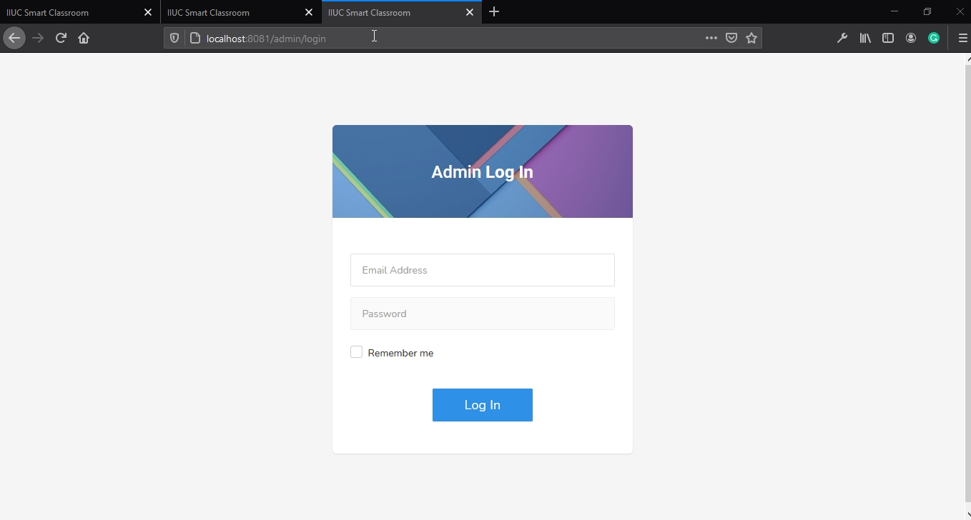

8.5.2 Admin Dashboard

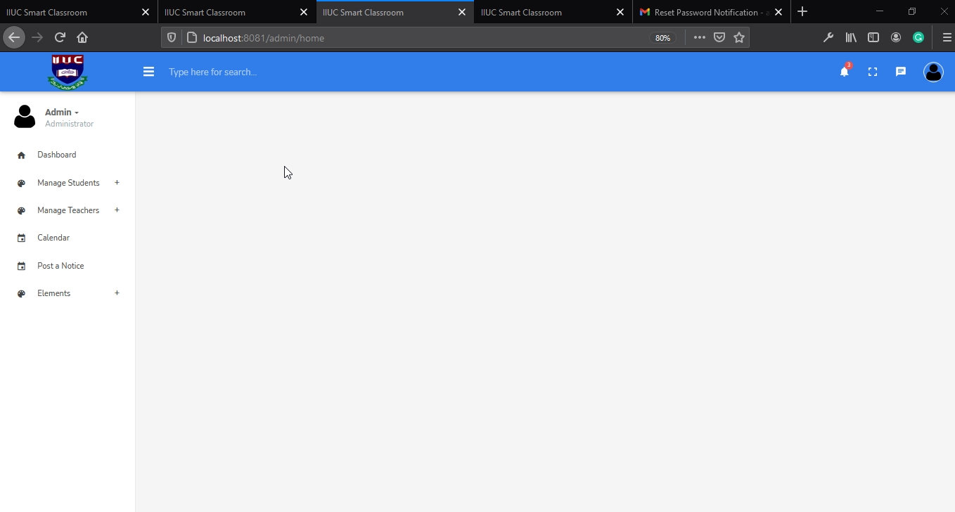

8.5.3 Admin add student

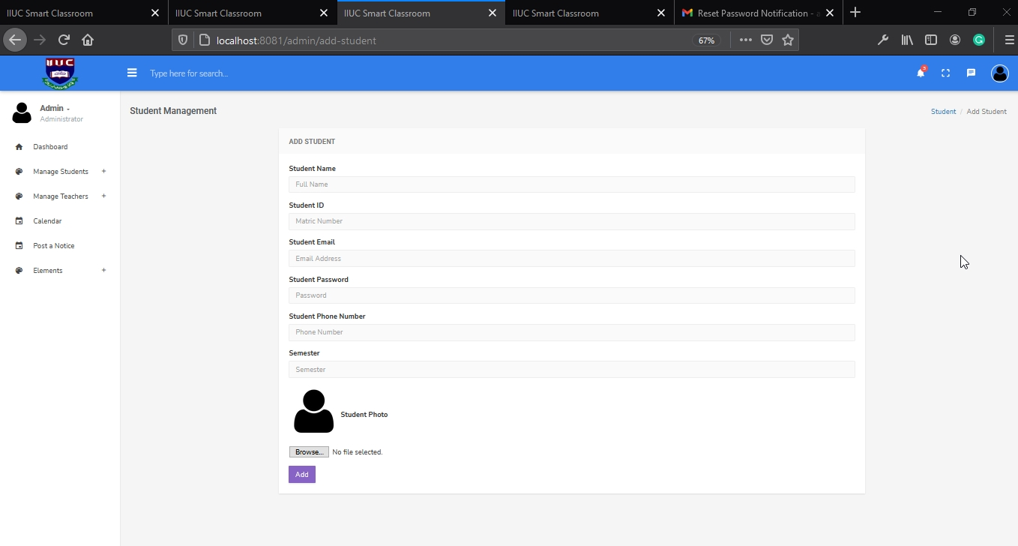

8.5.4 Admin manage all students

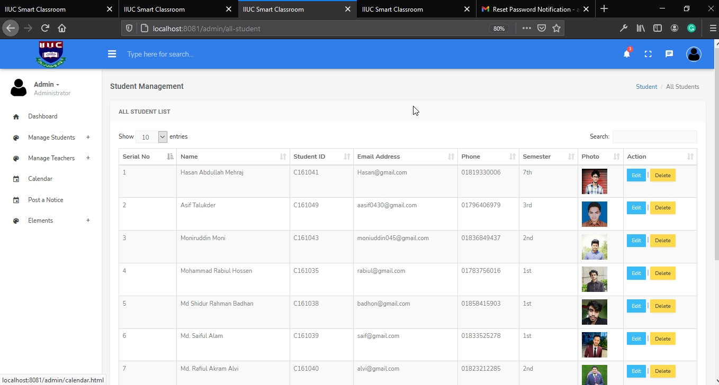

8.5.5 Admin update student profile

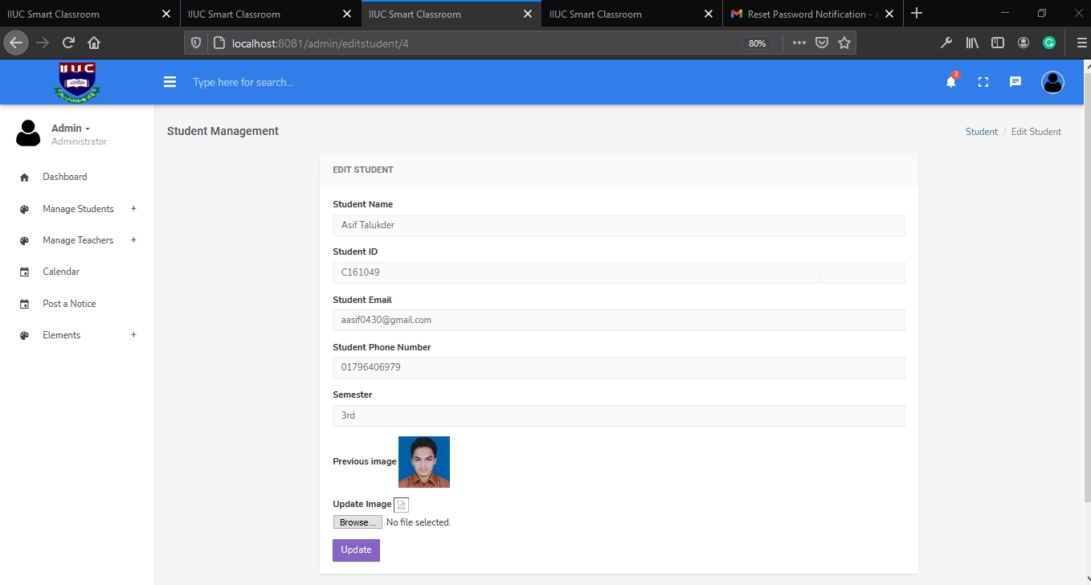

8.5.6 Admin add teacher

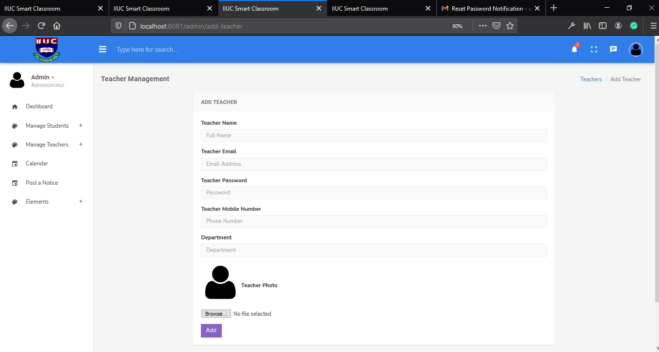

8.5.7 Admin manage all teachers

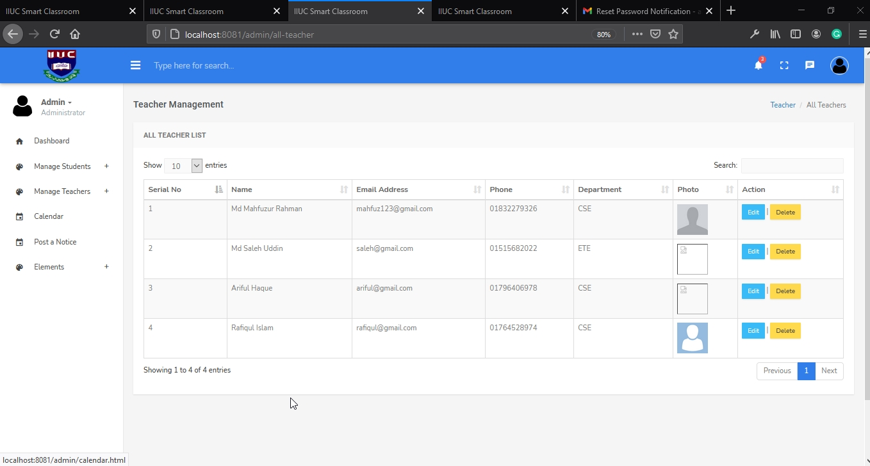

8.5.8 Admin update teacher profile

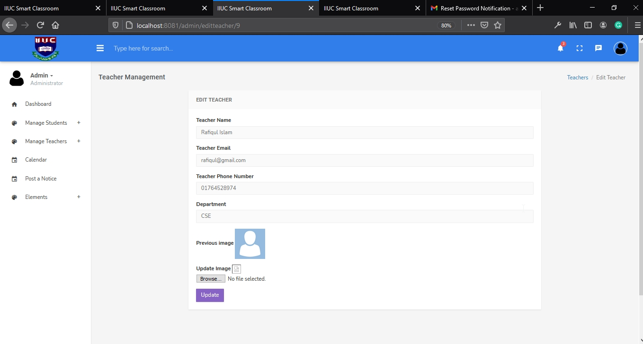

8.5.9 Student Login

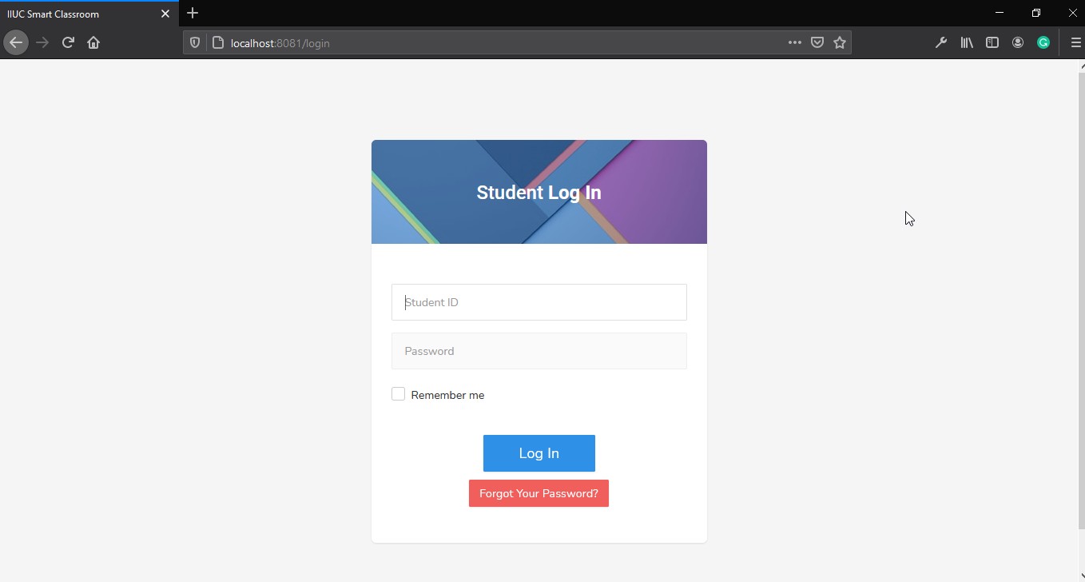

8.5.10 Student dashboard

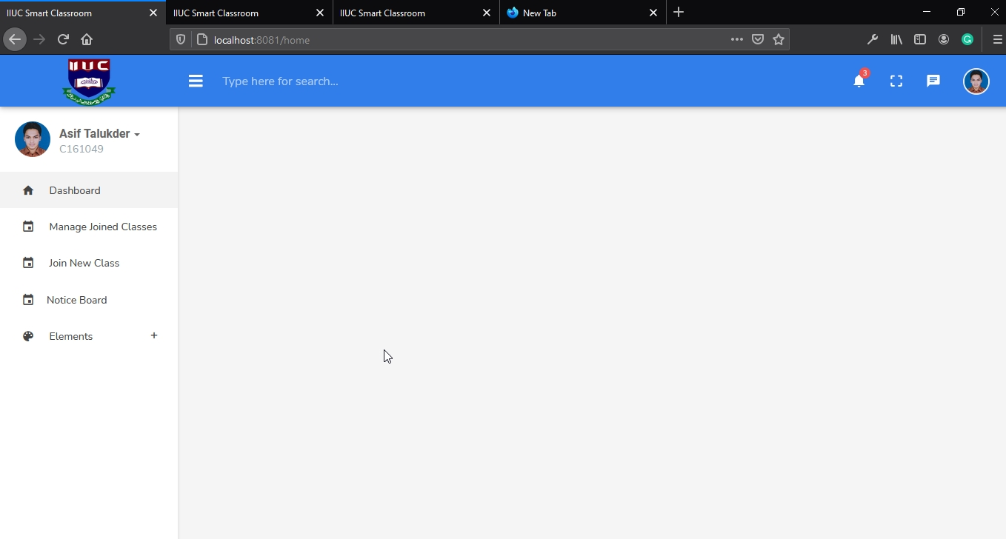

8.5.11 Student join new class

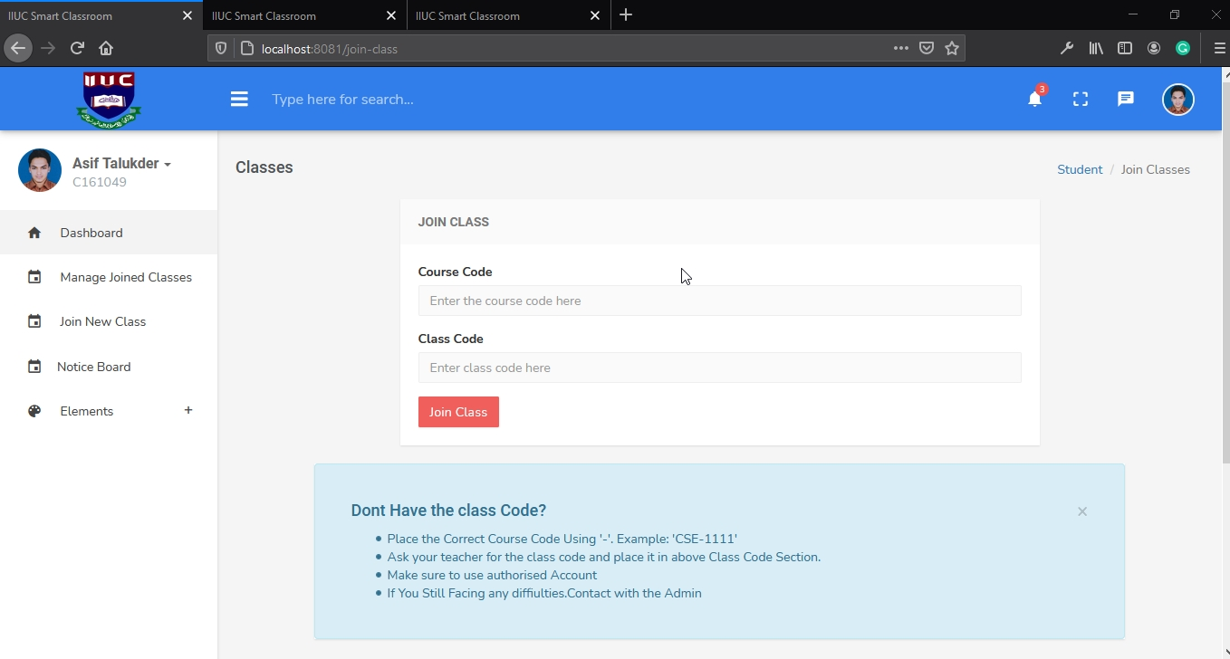

8.5.12 Student joined new class

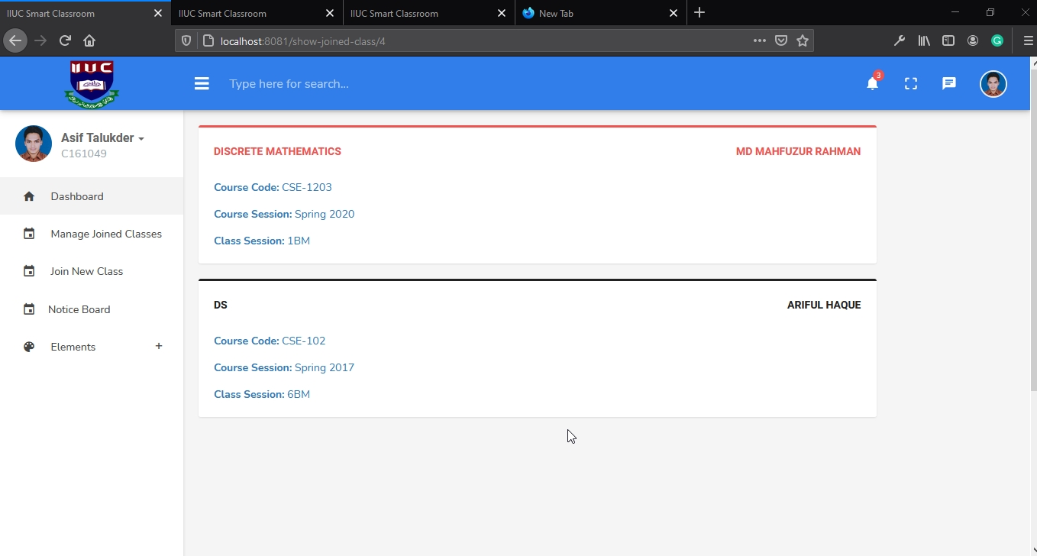

8.5.13 Student view class

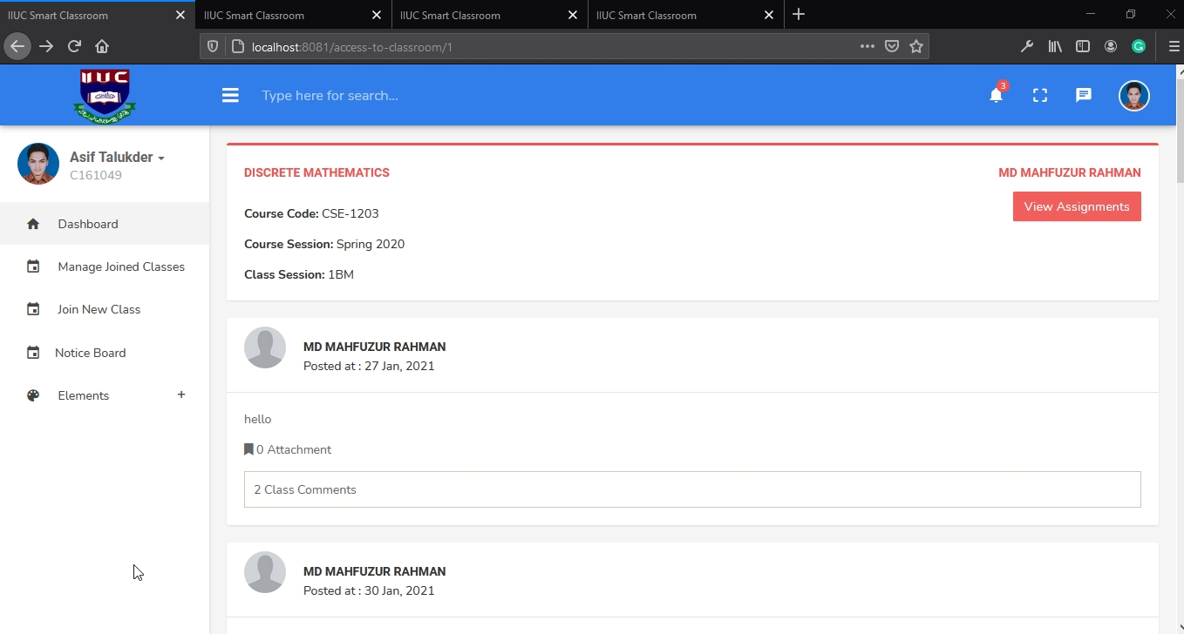

8.5.14 Student comment in class

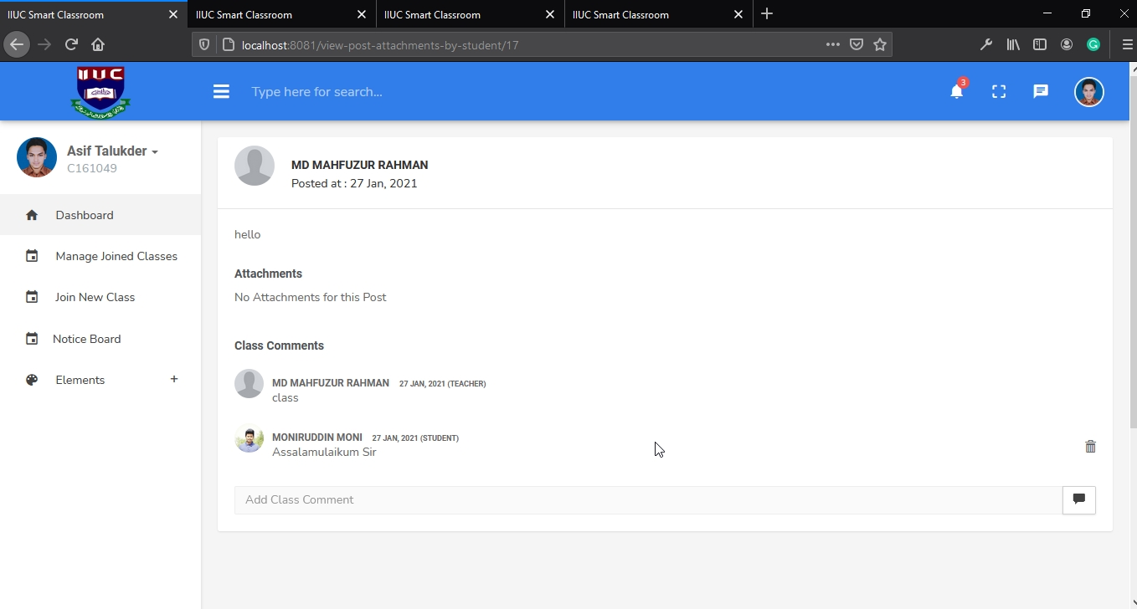

8.5.15 Student view assignment

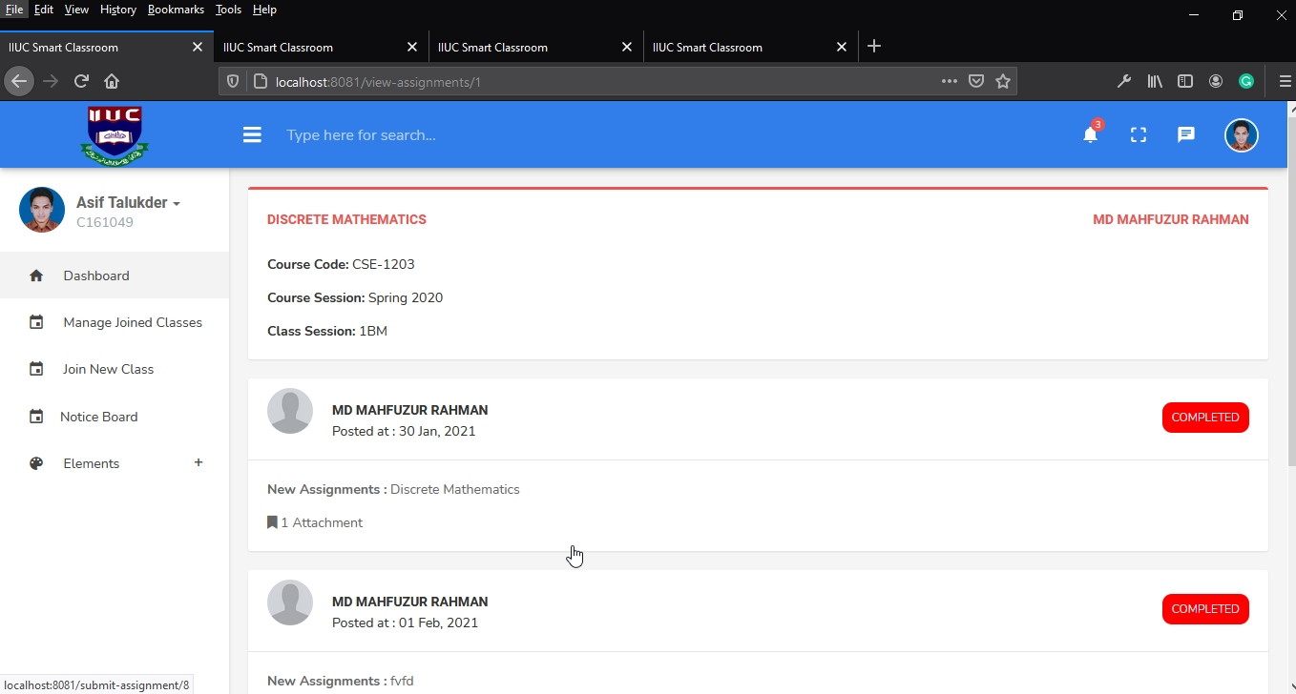

8.5.16 Student view assignment details with time

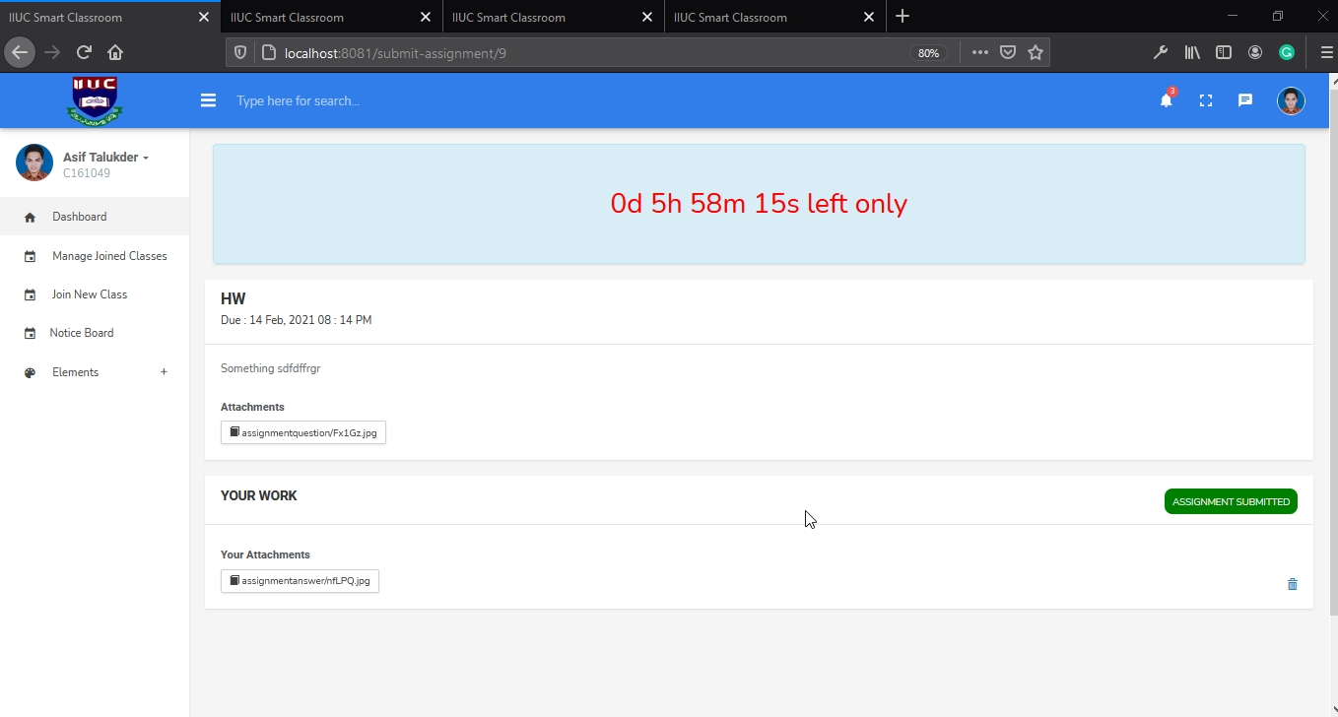

8.5.16 Student find new notice in notice board

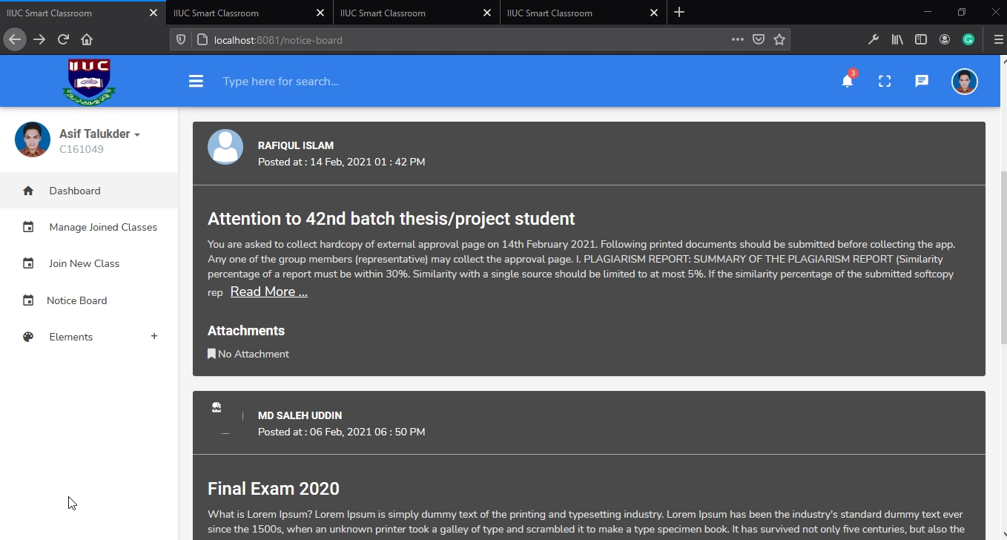

8.5.17 Student profile

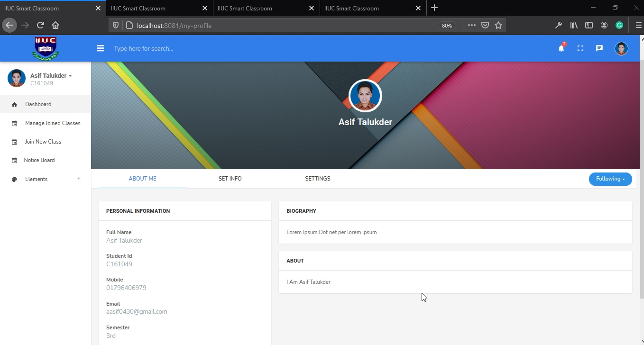

8.5.18 Student edit profile information

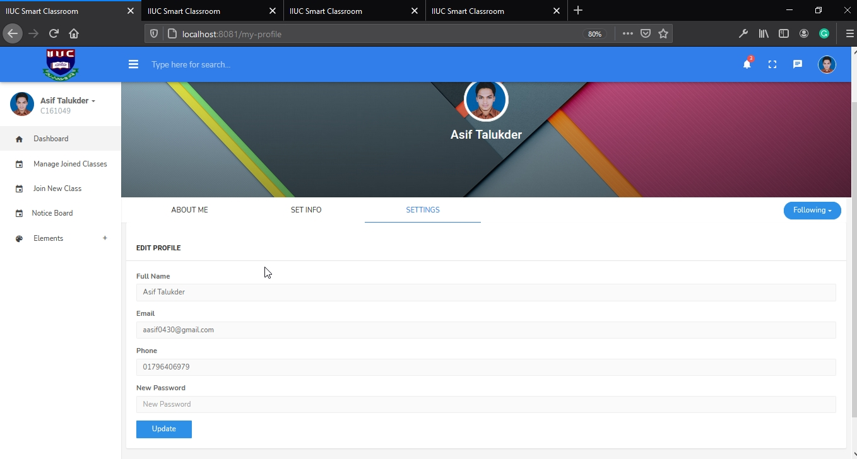

8.5.19 Student set information

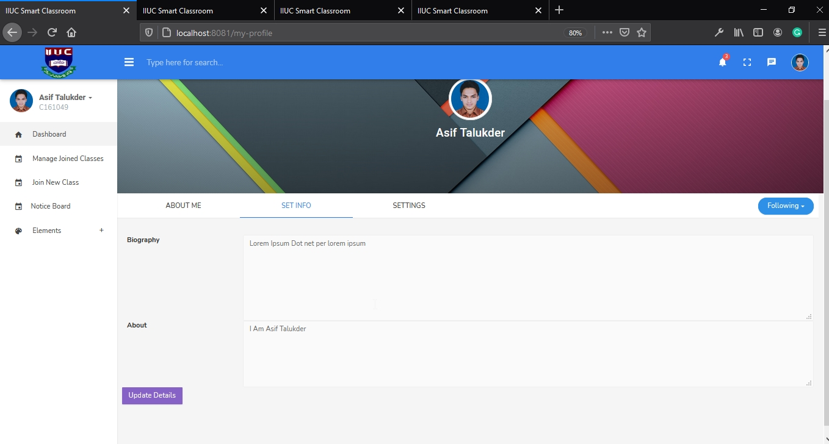

8.5.20 Student password reset

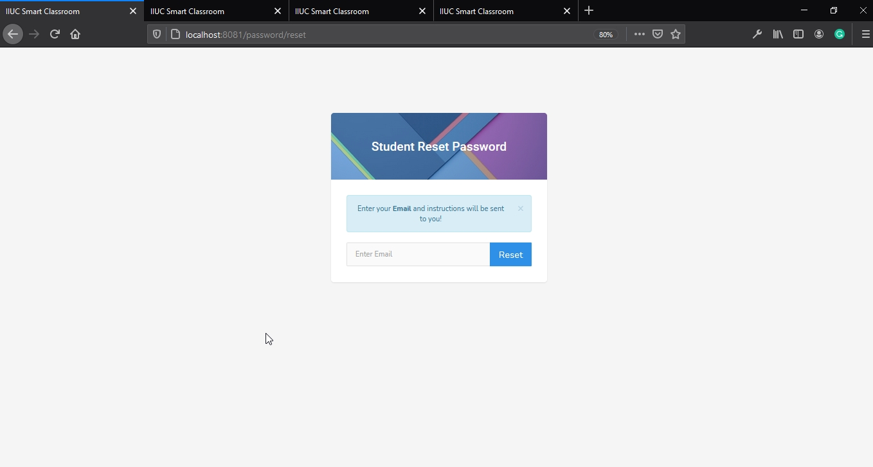

8.5.21 Student password reset update

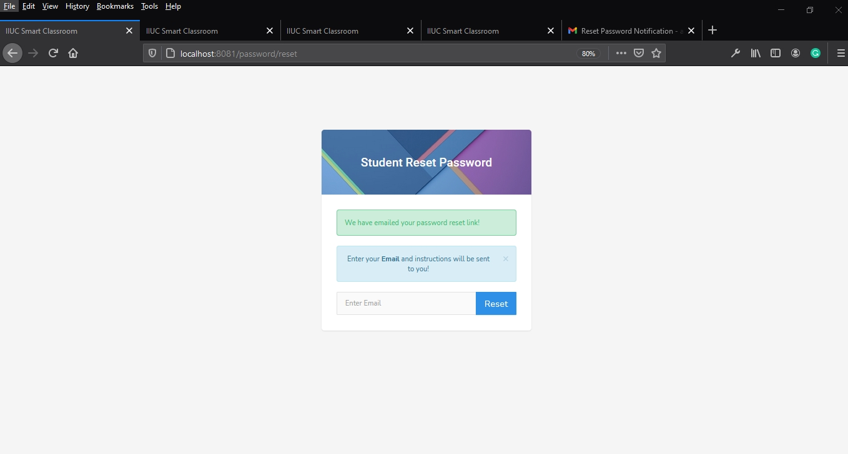

8.5.22 Student receive password reset mail

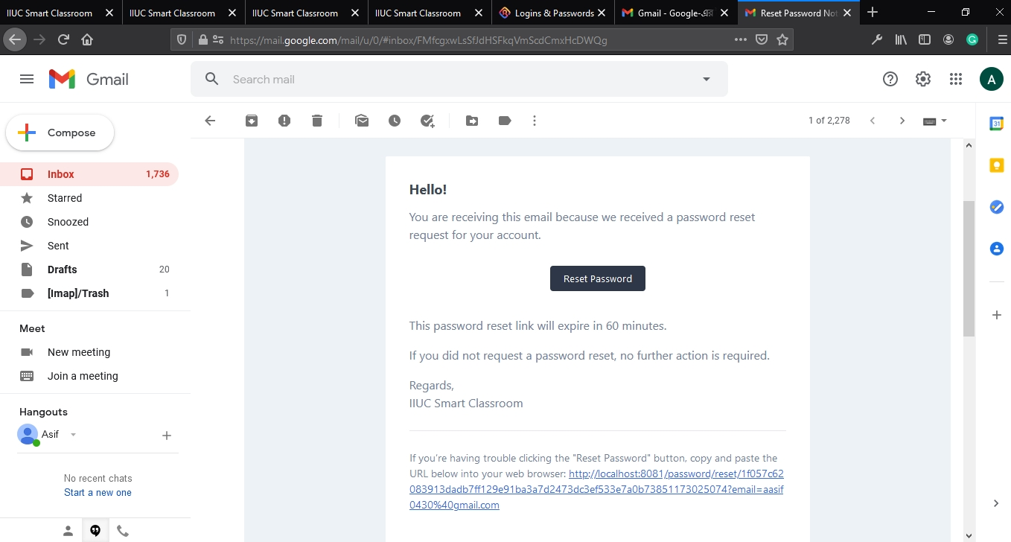

8.5.23 Teacher login

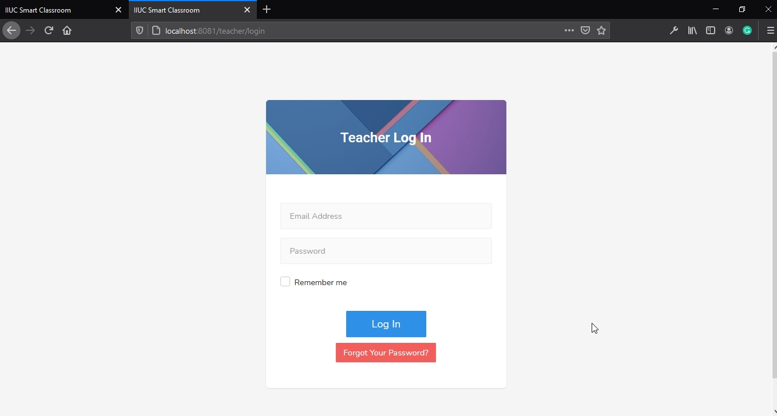

8.5.24 Teacher dashboard

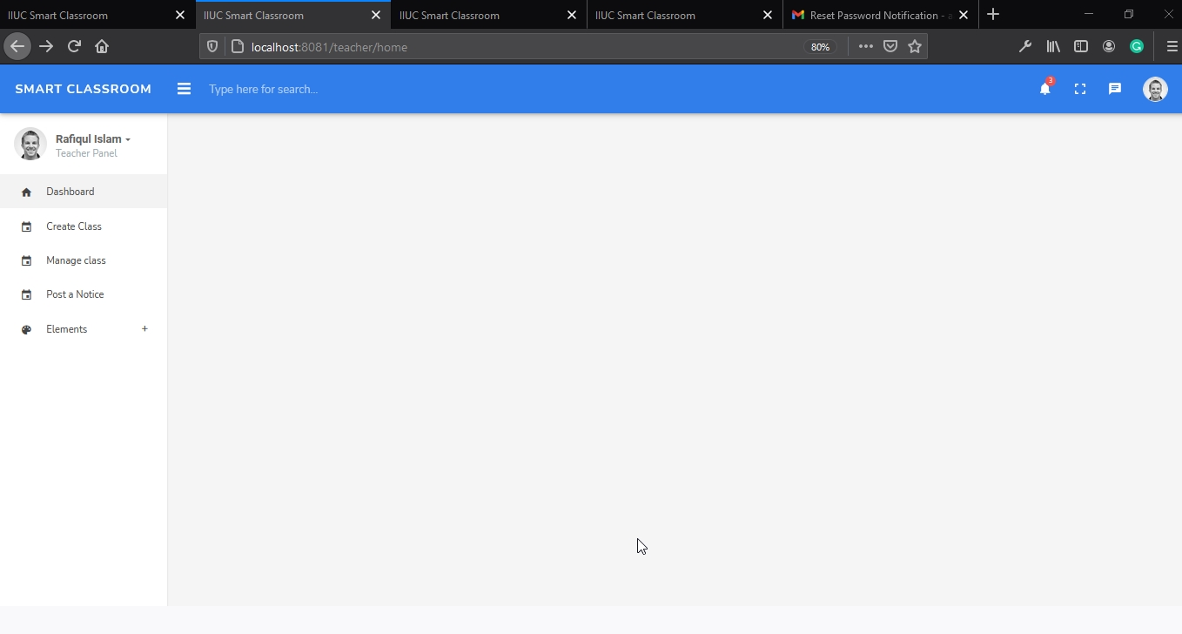

8.5.25 Teacher create classroom

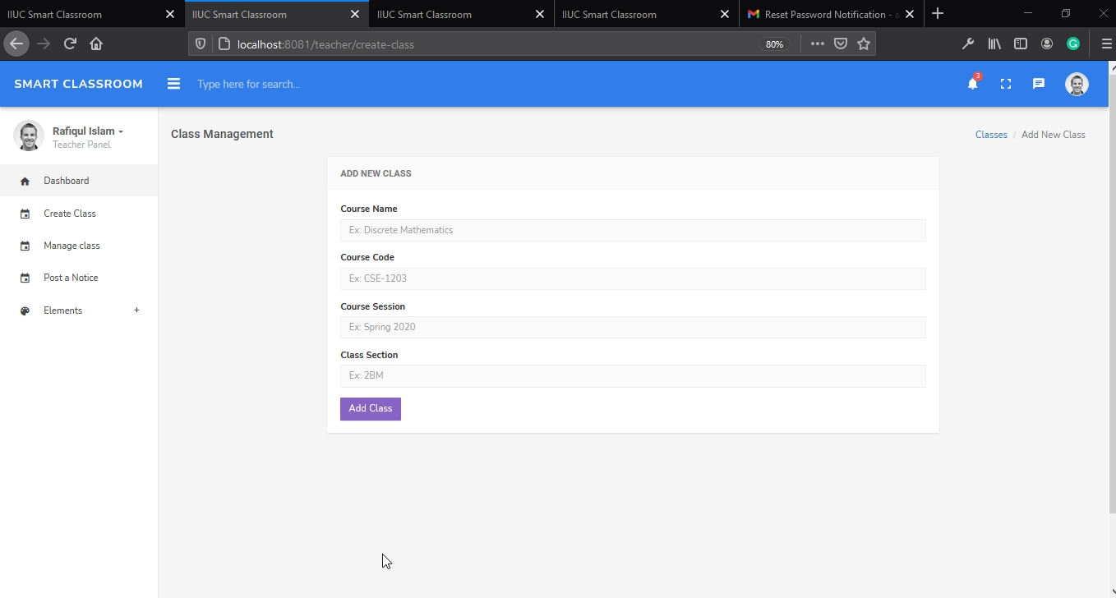

8.5.26 Teacher manage class

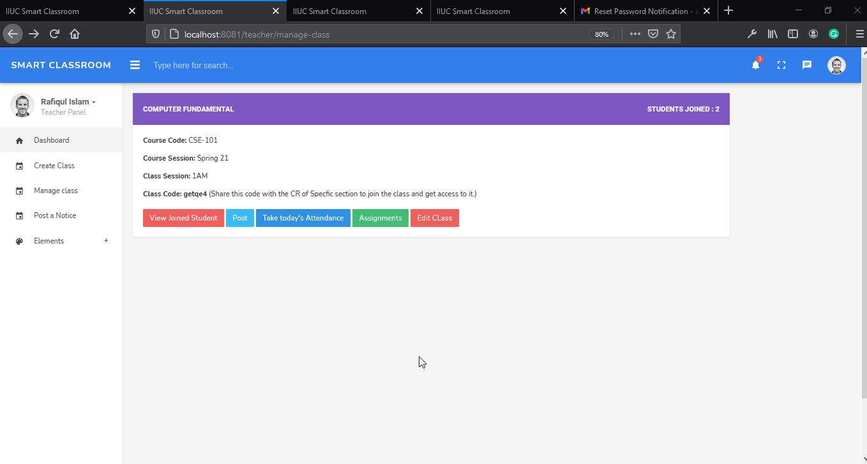

8.5.27 Teacher post in Class

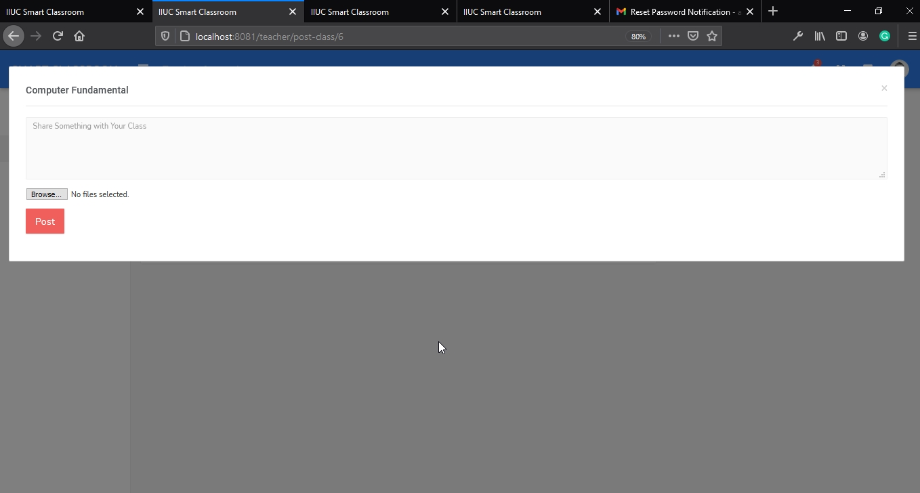

8.5.28 Teacher post in class

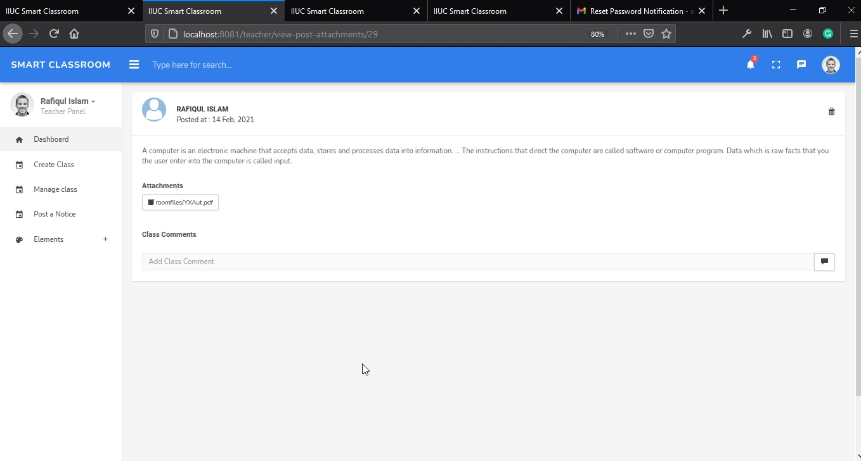

8.5.29 Teacher view joined student

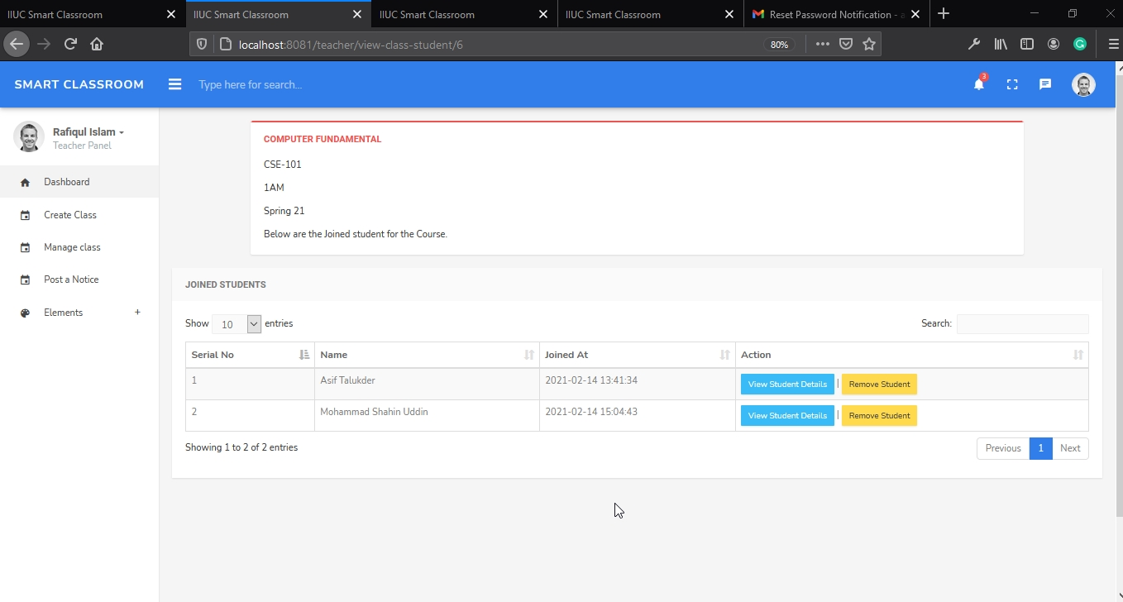

8.5.30 Teacher can search student

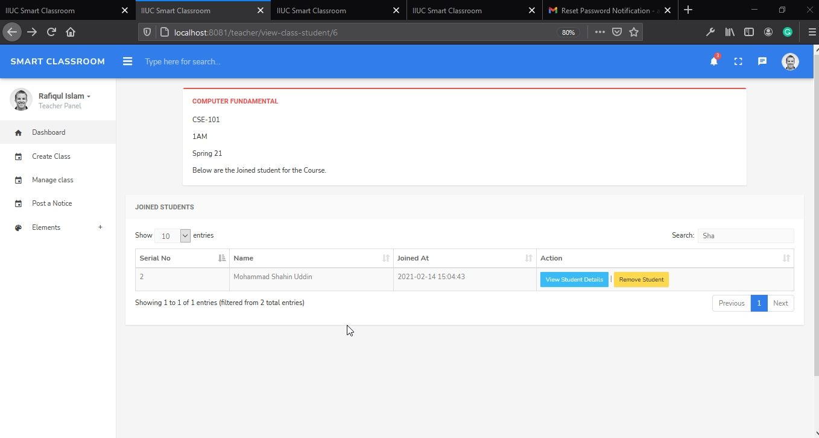

8.5.31 Teacher post assignment

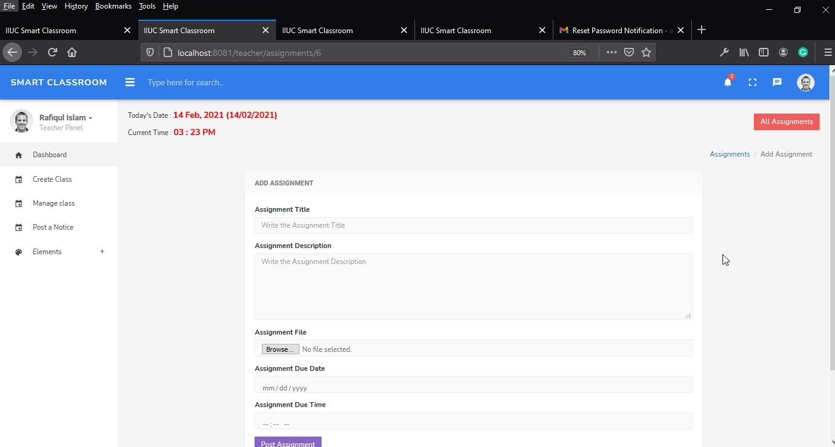

8.5.32 Teacher view all assignment

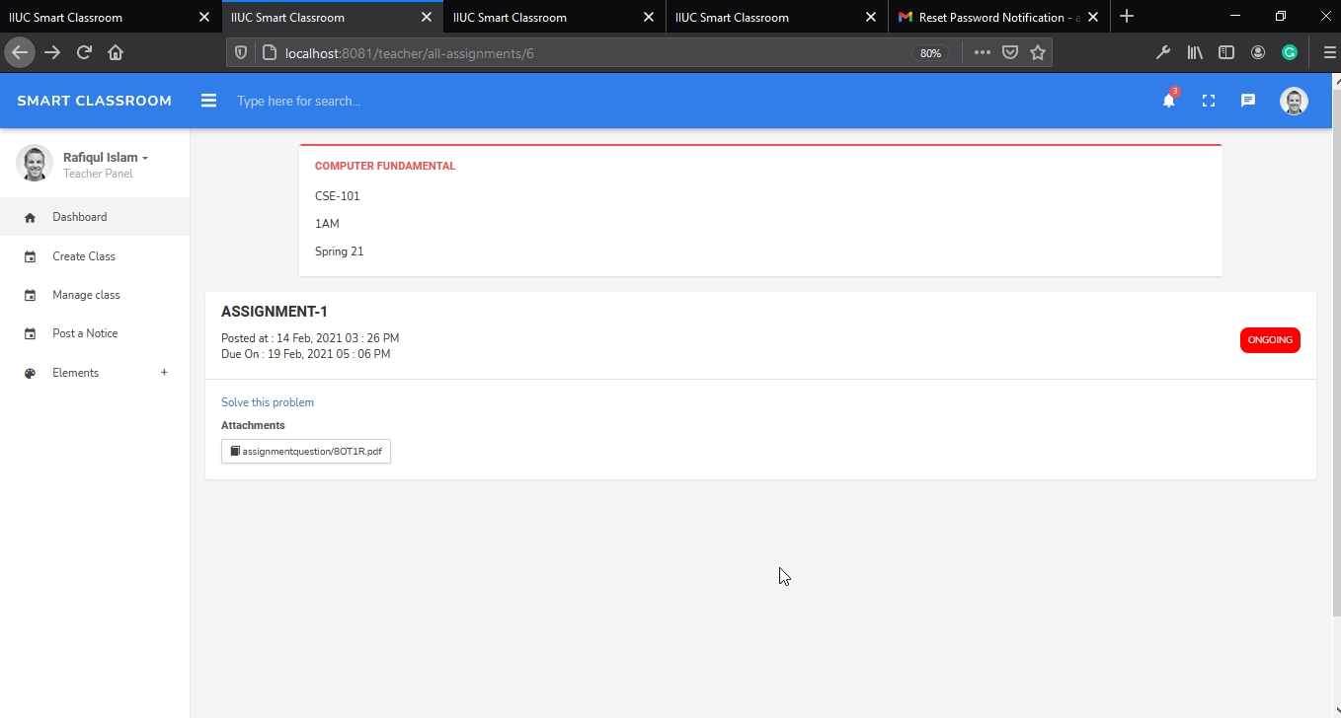

8.5.33 Teacher can view student assignment submission

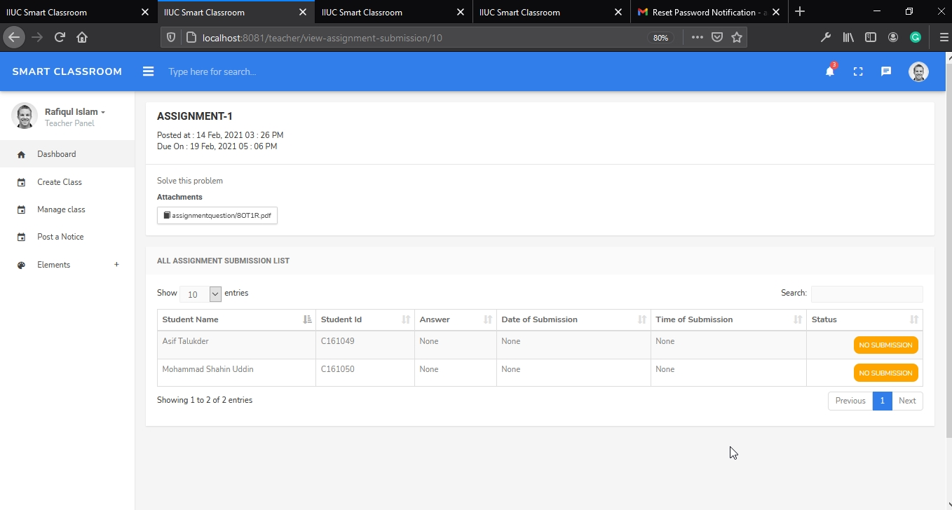

8.5.34 Teacher post notice

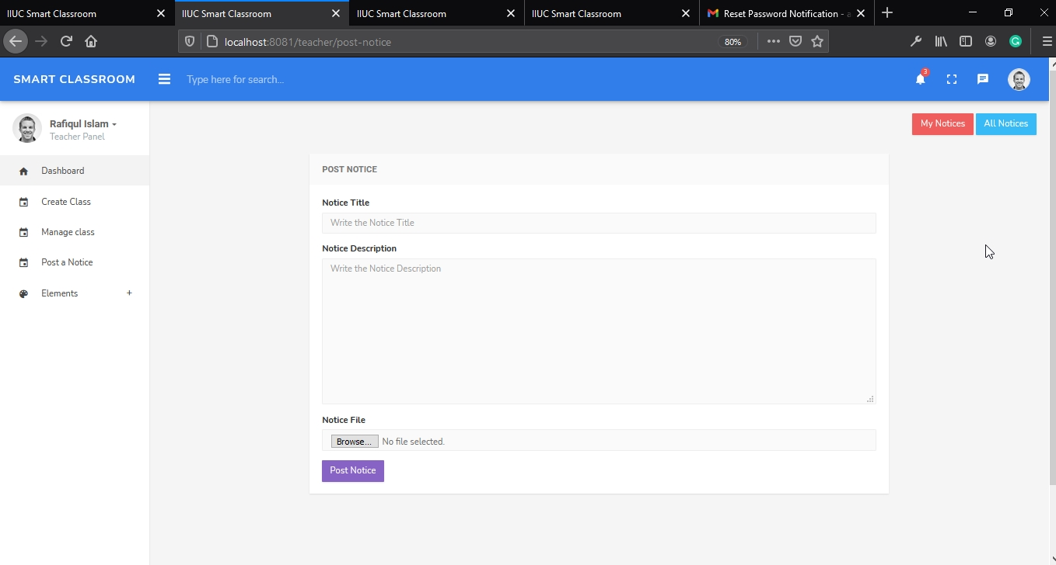

8.5.35 Teacher can delete his notice

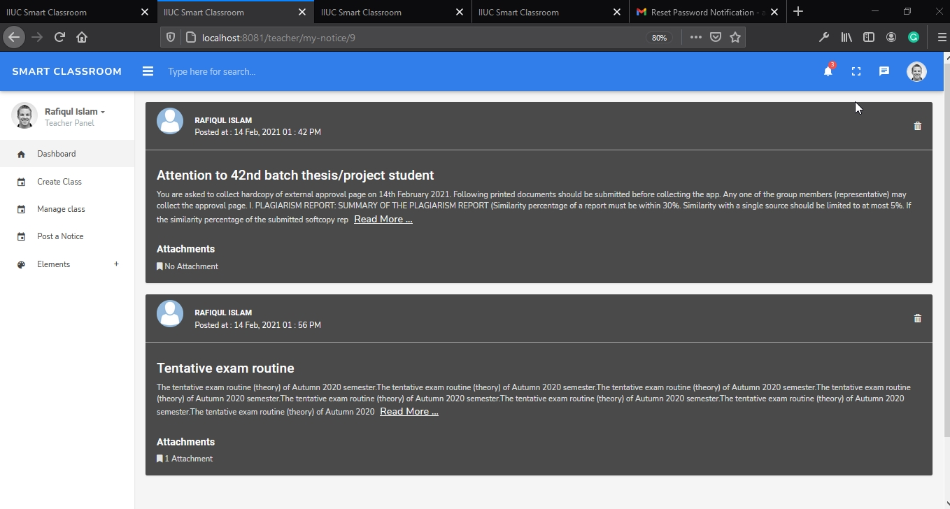

8.5.36 Teacher view all notices

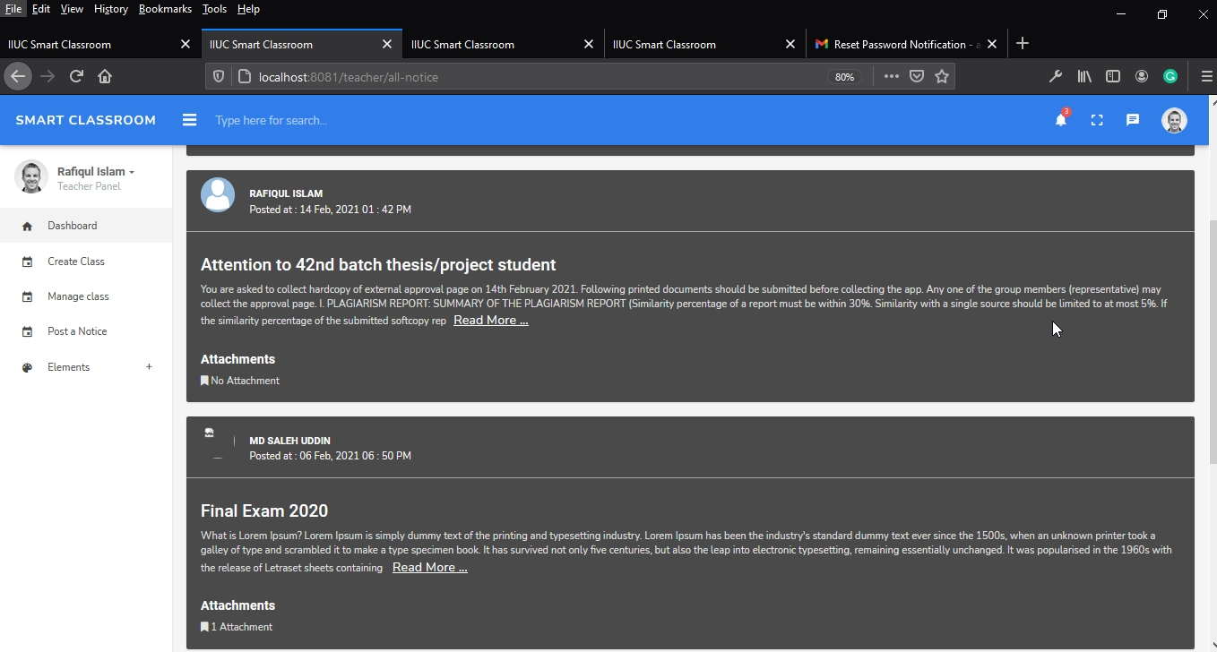

8.5.37 Teacher take attendance

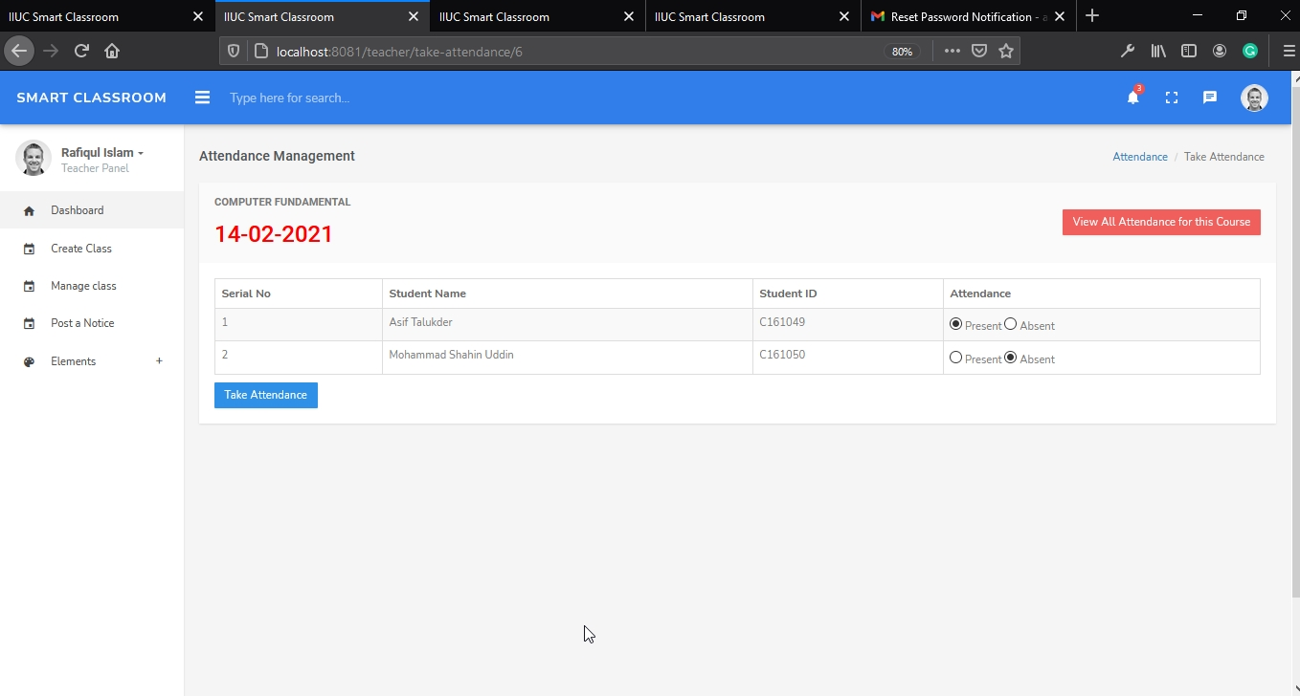

8.5.38 Teacher view all attendances by date

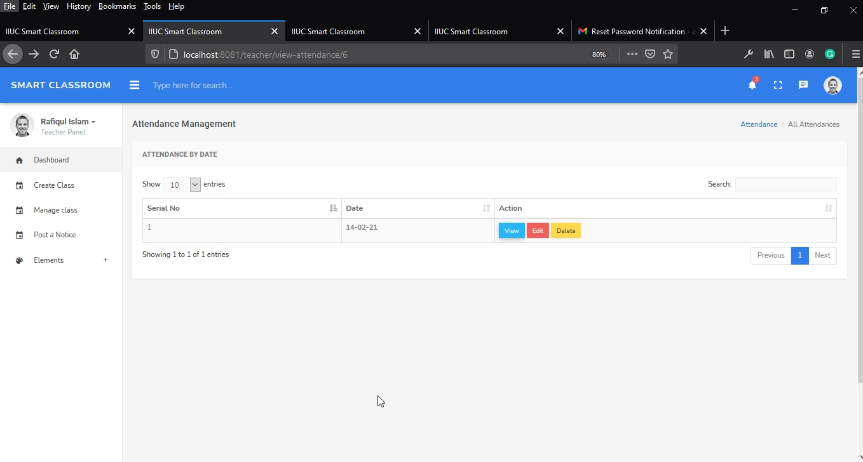

8.5.39 Teacher view student details

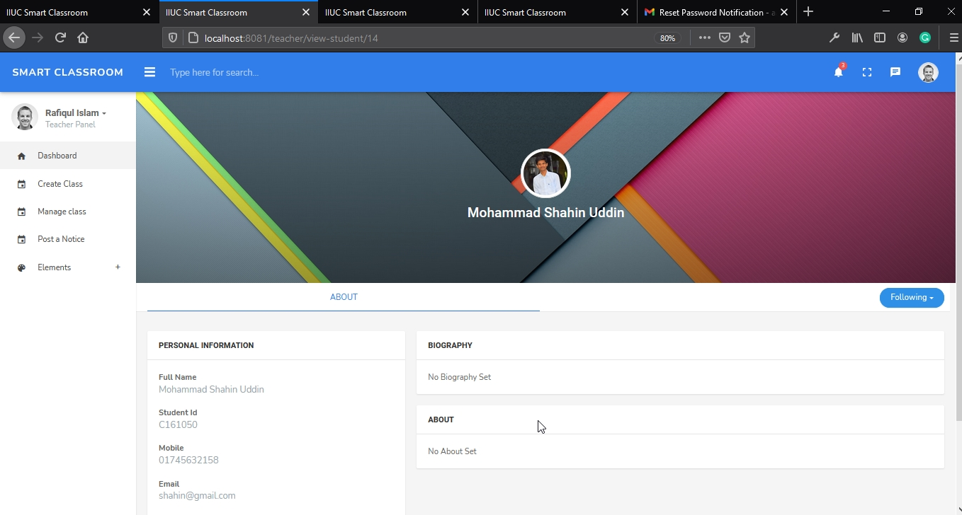

8.5.40 Teacher can remove a student

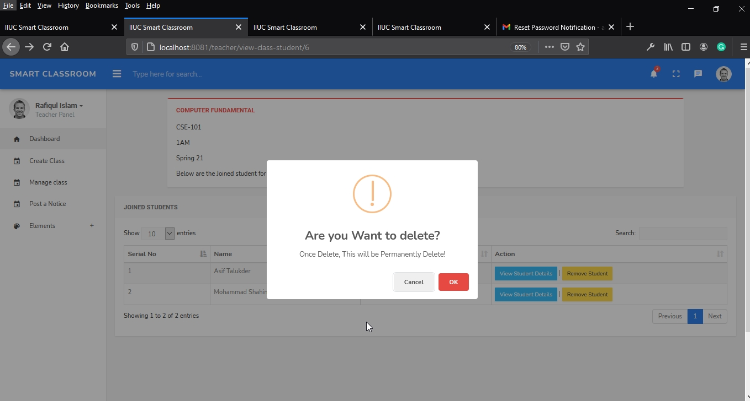

8.5.41 Teacher update class information

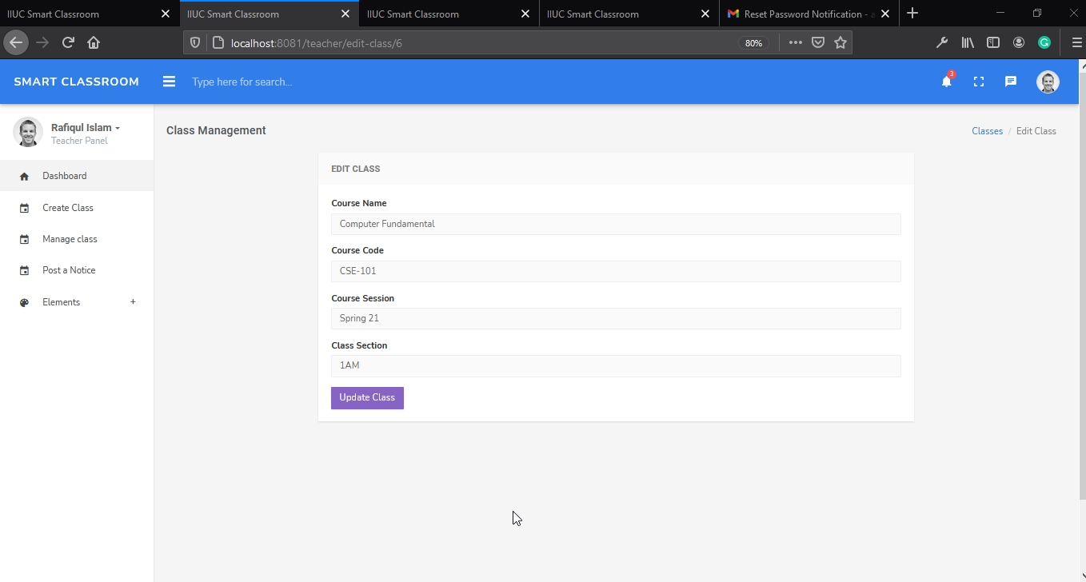

* 1. Testing

Testing helps to the operation of a system or application under a controlled condition and evaluating the results. The controlled conditions of the system should include both normal and abnormal conditions. Testing is intentionally attempting to make things go wrong to determine if things happen when we should not or things do not happen when we should.

9.1 Testing

Testing is the process that is carried out to ensure that the system conforms to the specifications and meets the requirements of the users, namely vendors and products. Functional and interface testing were carried out for the module or for the whole system. Besides, we used Appium which is an open source framework that allows us to conduct automation testing of mobile applications on different platforms like android. It automates the testing for: Native Mobile Applications that are written using android.

9.2 Testing Methods

These are two fundamental ways to test a system; those have been followed to implement a successful system; these are:

· Knowing the specified function that a product has been designed to perform, tests can be conducted that demonstrate each part is fully operational.

· Knowing the internal working of a product, tests can be conducted to ensure based on the above two points, testing methods can be classified into different types.

9.3 Basic of software testing

There are two basics of software testing: black box testing and white box testing.

9.3.1 Black Box Testing:

Black Box Testing which is known as behavioral, opaque-box, closed-box, specification-based or eye-to-eye testing. We use this software/Application Testing method that analyses the functionality of a software/application without knowing much about the internal structure/design of the item that is being tested and compares the input value with the output value. By using this testing the main focus in Black Box Testing is on the functionality of the system as a whole. The term ‘Behavioral Testing’ refers to Black Box Testing. Behavioral test design is slightly different from the black-box test design because the use of internal knowledge isn’t strictly forbidden, but it’s still discouraged.

Some examples of our black box testing are given below:

|  |  |  |  |  |
| --- | --- | --- | --- | --- |
| Test Source | Input | Expected Output | Output | Comment |
| Email | aasif0430@gmail.com | Accepted | Not Accepted | Valid email address but already  registered. Solved further. |
| Address |  | Not accepted | Not accepted | Address must be filled. |
| Mobile No | 017964069795 | Not accepted | Not accepted | Mobile number must be 11 digits.. |

### Table 9.3.1 Black Box Testing

9.3.2 White Box Testing:

White box testing is a testing technique that examines the program structure and derives test data from the program logic/code. The other names of glass box testing are clear box testing, open box testing, logic driven testing or path driven testing or structural testing.

9.4 Types of Testing

· Unit Testing

· Integration Testing

· Functional Testing

· System Testing

· Stress Testing

· Performance Testing

· Usability Testing

· Acceptance Testing

· Regression Testing

9.4.1 Unit Testing

During Unit Testing, test cases we have designed to verify that an individual unit implements design decisions made in the unit’s design specification. Through unit test specification we have included positive testing where the unit does what it is supposed to do and also negative testing where the unit does not do anything that it is not supposed to do. Main purpose is to validate that each unit of the software performs as designed.

|  |  |  |
| --- | --- | --- |
| Test Procedure | Output/Error | Analysis of Test Result |
| Login as teacher with valid login ID and password. | Teacher is redirected to the admin home order system. | Successfully redirected to the Teacher home after the system checks the validity of login ID and password. |
| Invalid login ID, password and number. | Error message is displayed. | Login is denied and an error message of wrong login ID and password. |
| None | Message is displayed requesting the admin to insert the required fields. | Login denied and a message is displayed requesting to insert the required fields. |

### Table9.4.1(a) Unit testing for Teacher login

|  |  |  |
| --- | --- | --- |
| Test Procedure | Output/Error | Analysis of Test Result |
| Search the student who are in the classroom | Searching student is redirected to the teacher dashboard page which contains the search information with details | Successfully redirected to the teacher dashboard page, which contains the search information. By selecting the student id |

Table 9.4.1(b) : Unit testing for Students search module.

9.4.2 Integration Testing:

Integration testing is a logical extension of unit testing .This purpose is to ensure the distinct components of the application still work in accordance to the customer in line or differences are explainable or acceptable based on the user input.

|  |  |  |
| --- | --- | --- |
| Test Procedure | Output/Error | Analysis of Test Result |
| Search the student availability by inserting the student name .  Update the student information | Student are viewed which has the all informationn.  Update student information | Successfully found student and update his information |

Table9.4.2(a): Integrated Testing for pickup request and tracking

9.4.3 Functional Testing

In functional testing we have checked software/application to ensure that it has all the required functionality that's specified within its functional requirements. It fails under the class of black box testing.

9.4.4 System Testing

In system testing we have tested to ensure that by putting the software/application in different environments (e.g., devices) it still works. It is the testing of a complete and fully integrated software/application product. It fails under the class of black box testing.

9.4.5 Stress Testing

In stress testing we have tested to evaluate how a system behaves under unfavorable conditions. Testing is conducted at beyond limits of the specifications. It fails under the class of black box testing. There are some issues but in further we updated and resolved.

9.4.6 Performance Testing

In performance testing we have tested to assess the speed and effectiveness of a system and to make sure it is generating results within a specified time as in performance requirements. It has measured the quality attributes of the system, such as scalability, reliability and resource usage.

9.4.7 Usability Testing

In usability testing is performed to the perspective of the client to evaluate how the GUI is user-friendly? How easily can the client learn? How pleasing it is to use its design? This fails under the class of black box testing.

9.4.8 Acceptance Testing

Acceptance testing is often done by the users to ensure that the delivered meets the requirement and works as the users expected. The main purpose of this test is to evaluate the system's compliance. This fails under the class of black box testing.

9.4.9 Regression Testing

In regression testing we focused on ensuring that changes (enhancements or defect fixes) to the software/application have not adversely affected it. It fails under the class of black box testing.

9.5 Conclusion

The system can further be enhanced to meet the user’s requirement. All the devices Interaction factors and the usability factors had been taken when designing the web portal. The web portal has allowed all age groups to use and navigate easily. The web portal provides a lot of information for users who would like to purchase for those who are interested to know about the system.

cHAPTER-X coNCLUSIOn

By using Smart Classroom and notice management system platform our faculty members and students will be greatly benefitted. Moreover this platform can be export by customize the features to the other university as their requirements. We believe that, in order to create a digitally advance country in true sense it would be very much helpful.

10.1 Future Plan of smART CLASSROOM & NOTICE MANAGEMENT SYSTEM

Some of the future works of this project will be take into the enhanced system. They are-

- Include exam system

- Android and IOS application

- More user-friendly interface

References

<https://www.w3schools.com/html/>

<https://www.guru99.com/learn-software-requirements-analysis-with-case-study.html>

<https://www.guru99.com/database-design.html>

[https://www.tutorialspoint.com/software_engineering/software_development_life_cycle. htm](https://www.tutorialspoint.com/software_engineering/software_development_life_cycle.htm)l

[https://www.conceptdraw.com/examples/example-of-data-flow-diagram-in-system-analy sis-and-design](https://www.conceptdraw.com/examples/example-of-data-flow-diagram-in-system-analysis-and-design)

<https://code.visualstudio.com/download>

<https://www.geeksforgeeks.org/software-testing-basics/>

<https://www.javatpoint.com/software-engineering-requirement-analysis>

https://www.tutorialspoint.com/software_architecture_design/introduction.htm